A Web and Mobile Based Point of Sale Management System for AquaLicious Water Refilling Station with Data Analytics

A Thesis Presented to the Faculty of
Institute of Computing Studies and Library Information Science
City College of Angeles
Angeles City



In Partial Fulfillment of the Requirement for the Degree
Bachelor of Science in Computer Science

By:
Juliene Rei Bondoc
Leian L. Gabrido
Khylster Von Jomar D. Mananis
Shaina Marie S. Serrano
Mark Harvey S. Tapang

March 2026

INTRODUCTION
Background of the Study
The role of small business enterprises is vital to the local economy, especially in places where basic needs are always in demand. In Angeles City, Pampanga, small retail businesses such as water refilling stations serve as essential service providers in the community, offering affordable and clean drinking water to residents. Among these establishments is AquaLicious Water Refilling Station, a small locally-owned business located in Angeles City that supplies mineral water per gallon and bottled water to its customers. AquaLicious plays a meaningful role in its community by providing a basic health service while also generating local employment. However, like many small retail businesses in the area, AquaLicious continues to rely on traditional and manual methods for managing its day-to-day business operations.
Based on an interview conducted with Maya Y. Dizon, the owner of AquaLicious Water Refilling Station, the business is currently records its sales transactions using a physical ledger or notebook. The owner reported experiencing recurring problems with this method, including duplicate entries, incorrect calculations, and time-consuming recording process. When asked to rate the efficiency of their current sales and inventory recording process, the owner gave it a rating of 5 out of 10, indicating a moderate level of dissatisfaction with the existing system. The owner also reported that errors in recording is time-consuming. These firsthand accounts highlight the three core operational challenges that AquaLicious currently faces: inefficient sales transaction recording, disorganized inventory management, and the absence of data analytics to support business decision-making.
Advancements in digital technology have greatly improved how businesses manage their operations, especially in handling sales processing, inventory management, and financial reporting. Point of Sale (POS) systems have proven to be an effective tool for businesses in these areas. As stated by Lopez & Martinez (2023), POS systems have helped businesses efficiently manage their activities, especially in financial reporting. In addition, web-based POS systems have been effective since they allow businesses to access their systems using internet browsers and are not limited to expensive hardware installations. Jonathan & Cruz (2024) stated that, web-based POS systems are most suitable for use by small-scale businesses.
The integration of mobile technology further improves the flexibility and functionality of POS systems. A web and mobile-based POS system allows business owners and employees to manage transactions and control business operations using their mobile phones or tables. In the study of Chavez & Tan (2023), business organizations using a digital POS system can enjoy accurate transactions and minimize business operations errors. This is especially relevant for water refilling stations like AquaLicious, which require efficient and real-time management of transactions on a daily basis.
Modern POS systems are also integrated with data analytics tools that can give valuable information to business owners. Using data analytics tools in a POS system allows business owners to analyze sales patterns, peak hours, and bestselling items. As stated by Villanueva (2022), data analytics can assist businesses in forecasting and improving decisions. This is particularly significant for the owner of AquaLicious, who expressed during the interview that data analytics features — specifically those capable of processing sales data and turning it into actionable business insights — would be highly beneficial for improving the way the station is managed.
Despite these advantages, the use of digital POS systems remains low among small businesses. In the research of De la Cruz (2022), reasons for low adoption incudes the lack of technical knowledge, the perception of high costs, and limited awareness of the benefits of digital tools. For small businesses like AquaLicious in Angeles City these barriers are especially evident, as most operations continue to be managed through manual and paper-based methods that are increasingly insufficient for meeting the demands of a growing customer base.
In light of these challenges, this study seeks to design and develop a Web and Mobile Based Point of Sale Management System for AquaLicious Water Refilling Station with Data Analytics. The proposed system aims to address the operational problems identified through the interview with the business owner by providing a digital solution for accurate sales recording, organized inventory management, and data-driven business insights. This study seeks to contribute to the efficiency, accuracy, and overall sustainability of AquaLicious Water Refilling Station as a small business operating in the local community of Angeles City.
Statement of the Problem
AquaLicious Water Refilling Station tracks sales and inventory using outdated methods like notebooks, just like many other small retail shops. A more effective approach to tracking, organizing, and analyzing data may prevent waste and errors. A more efficient method of tracking inventory levels and recording sales would result in insightful data. These factors demonstrate the necessity of a web and mobile-based solution.
This study specifically seeks to address the following:
- AquaLicious Water Refilling Station's current method of recording sales transactions through a physical ledger is time-consuming and inefficient.
- Inventory management at AquaLicious Water Refilling Station is disorganized and unreliable, making it difficult for the owner to accurately monitor stock levels and determine when products need to be restocked.
- The absence of a data analytics feature prevents the owner of AquaLicious Water Refilling Station from analyzing sales patterns, identifying top-selling products, and monitoring overall business performance.
Objectives of the Study
The main goal of this study is to develop a Web and Mobile Point of Sale (POS) System with Data Analytics in order to enhance AquaLicious Water Refilling Station functionality. The system’s objective is to improve efficiency, reduce errors, and provide useful data for improved decision-making.
This study specifically seeks to:
- To develop a system that records sales transactions faster and more efficiently by replacing the current manual notebook-based method with a digital mobile POS interface, enabling store employees to process transactions accurately and in real time.
- To develop an inventory management feature that provides real-time stock level monitoring and organized product tracking, and integrates a Reorder Point (ROP) Algorithm that automatically alerts the administrator when stock levels fall below the defined reorder threshold.
- To develop an integrated data analytics module that processes historical sales and inventory data to generate meaningful business insights analysis.
Scope of the Study
This study presents the design and implementation of a web and mobile-based POS Management System with Data Analytics for AquaLicious Water Refilling Station. The system seeks to solve challenges associated with sales recording and inventory management through the provision of a more efficient and organized digital system.
Considering the definition of existing problems and requirements of the system, the following scope and limits have been considered:
- The system is developed specifically for the AquaLicious Water Refilling Station to address its particular requirements and operational processes.
- The study focuses on the sales recording, inventory management, and business performance monitoring of the AquaLicious Water Refilling Station to improve the accuracy and efficiency of its daily operations.
- The system will be accessible through a Web-based administration system and an Android-based mobile application. The web application is intended for the administrator, while the mobile application is intended for customers.
Delimitation of the Study
This section presents the limitations and conditions that govern the boundary of the study. In other words, it specifies what will not be covered by the research.
This section defines the constraints or boundaries of the research, indicating the factors not to be included in this study. This study is only focused on the development and implementation of the web and mobile-based point of sale management system with data analytics for AquaLicious Water Refilling Station. The developed system was based on the operational requirements, sales transaction flow, and inventory control system of the business and therefore not designed for use by other business organizations such as supermarkets, convenience stores, restaurants, pharmacies, etc., because these business establishments have different operational flows, inventory structures, and transaction requirements from a water refilling station, and also they would require further adaptation of the developed system.
The study is limited to the development of a web-based administration system and an Android based mobile application. The mobile application was developed for Android devices and was not designed for use in Apple iOS-based devices such as iPhones, iPads, etc., or also for other operating systems of mobile phones. This constraint was given as only the owner and employee utilize the Android devices at AquaLicious Water Refilling Station, and time and resources are limited as much as possible. The features are limited to the core point of sale system features only, such as authentication of users, processing sales transactions, controlling inventory, managing customers, and report generation and analysis of the data. The features include summarized sales reports, visualization of the sales trends, monitoring of the stock, notification to reorder stock based on ROP (Reorder Point), and a simple sale prediction by the Simple Moving Average (SMA) algorithm.
The research did not implement a barcode reader, automated order placing to suppliers, online transactions, loyalty cards, an automated purchase ordering system, a human resources system, an integrated financial accounting module, an online delivery system, or complex decision-making through AI (artificial intelligence) features such as business intelligence, etc. In the role-based access control of the developed system, only an administrator is permitted to access certain functions such as product, stock, customer data, user management, report generation, etc., and employees will only be permitted to conduct business transactions, check the current stock, etc. Thus, there is no mention of different roles of the administrator or multiple or complex access control systems.
The integration with the other external system was not incorporated into the research, such as with the accounting system, supplier's database and information, banking system, government reports, etc. Instead, all business-related data, such as stock levels, sales data, customer data, and users' accounts, will be kept within the system itself with a dedicated centralized MySQL database for use in this system. For the system to work, there must be an available internet connection to allow for the transfer of data between the web-based system and the Android-based system. While the data are transmitted to update the sales data in the system and the inventory level in the system in real time, the study does not include offline transactions and synchronization upon connection to the internet. Hence, an unstable or disconnected connection may lead to data lag on the record being updated. Finally, the data analytics feature is just a basic analysis of the data.
The data analytics are aimed to aid the owner to monitor the daily operations and business performance through sales reports, sales trends, peak transaction period reports, stock status reports, ROP alerts, and also simple sales forecasting reports through SMA (Simple Moving Average). The developed system did not include intelligent data analysis, customer purchase trend analysis, predictive models based on artificial intelligence, or any sort of automatic decision support features. This finding of the research work focuses on the implementation and successful realization of a web- and mobile-based point-of-sale management system with data analytics for AquaLicious Water Refilling Station. Features and capabilities not mentioned or defined herein should be explored in future developments of the system.
Conceptual Framework
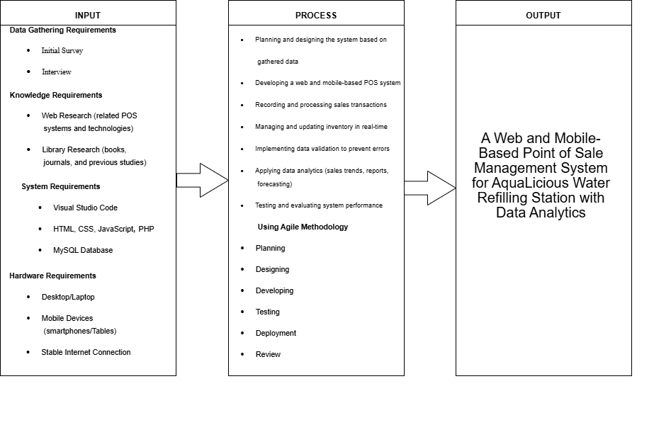
Small retail businesses require efficient transaction processing, and management to keep being competitive in order to remain in the growing digital economy. This study takes on the IPO model– Input-Process-Output model to assist in the development of the Web and Mobile Based Point of Sale Management System for AquaLicious Water Refilling Station with Data Analytics .
Figure 1. IPO Model
Figure 1 presents the conceptual framework of the study using the Input-Process-Output (IPO) model. This model illustrates the systematic flow of activities involved in the design and development of a web and mobile-based Point of Sale (POS) management system with data analytics for AquaLicious Water Refilling Station.
To explain the system in three ways: input, process, and output, the researchers used Input-Process-Output model or IPO model for representation. Inputs are what the researchers used for the system, as well as its requirements. Outputs are the result of the system itself that was done after the process where the inputs were applied in order to achieve the output.
The input phase consists of the necessary resources and requirements for system development. This includes knowledge requirements such as web research and library research to gather relevant information about POS systems and technologies. System requirements include development tools and technologies such as Visual Studio Code, HTML, CSS, JavaScript, PHP, and MySQL database. Hardware requirements, including desktop or laptop computers, mobile devices, and a stable internet connection, are also part of the inputs needed to support system development and deployment.
The process phase involves the planning, design, development, and evaluation of the system. It starts with planning and designing the system based on gathered data, followed by the development of a web and mobile-based POS system. Key processes include recording and processing sales transactions, managing and updating inventory in real-time, and implementing data validation to minimize errors. Data analytics is applied to generate insights such as sales trends, reports, and forecasts. The system is also tested and evaluated to ensure performance, accuracy, and reliability. The development follows an Agile methodology, which includes planning, designing, developing, testing, deployment, review, and launch to ensure continuous improvement and system effectiveness.
The output phase is the development of a functional Web and Mobile-Based Point of Sale Management System with Data Analytics for AquaLicious Water Refilling Station. The system provides automated and accurate sales recording, organized inventory management, and generated sales and inventory reports. It also includes data analytics and visualization features that support improved decision-making, reduce errors, and enable faster and more efficient business transactions.
Significance of the Study
The development of a web and mobile-based point of sale management system for AquaLicious Water Refilling Station with data analytics will benefit not only the owner and employees but also the customers and the local business community in Angeles City.
- To the Owner of AquaLicious Water Refilling Station. The proposed system directly addresses the challenges of using outdated manual methods like notebooks. Through data analytics, the owner will gain insightful information to track business performance accurately, organize inventory records, and make better-informed business decisions.
- To the Store Employees. The system will transform the time-consuming process of recording sales into a faster, automated workflow. By replacing manual entries with a digital interface, the risk of duplicate records and human errors is minimized, allowing employees to perform their tasks more efficiently.
- To the Customers. Customers will benefit from faster and more accurate transaction processing. Improved inventory management ensures that products are always available and that service quality remains consistent, leading to a better overall customer experience.
- To the Local Business Community in Angeles City. This study serves as a practical example of digital transformation for small retail shops. It encourages local entrepreneurs to move away from traditional recording methods and adopt modern technology to remain competitive in the digital economy.
- To the Researchers. The development of this web and mobile-based system provides the researchers with practical experience in database management, system integration, and data analytics. It enhances their ability to design technological solutions that solve real-world problems like data inaccuracy and operational delays.
- To Future Researchers. This study may serve as a valuable reference for future research related to POS systems and automated inventory management. It provides a foundation for further innovations in reducing manual errors and improving data organization for small-scale retail businesses.
Definition of Terms
The following terms are defined as they are used in this study to ensure clarity and consistent understanding of key concepts.
- Application Programming Interface (API) – refers to a group of protocols that allow different software components to communicate with one another.
- Authentication – refers to the process that verifies a user’s identity prior to granting them system access.
- Backend – refers to the server-side component responsible for managing data, carrying out logic, and maintaining the system.
- Database – refers to a systematic collection of structured data or information that is arranged and usually stored electronically in a computer system.
- Data Analytics – refers to the feature of the system that analyzes sales and inventory data to identify trends such as top-selling products, sales performance, and peak transaction periods.
- Data Validation – refers to the procedure for ensuring that input data is correct and follows the necessary formats.
- Frontend – refers to the system’s client-side component that controls interface appearance and user interaction.
- Inventory Management System – refers to the process of monitoring, updating, and controlling the stock levels of products available in AquaLicious Water Refilling Station using the system.
- Local Storage – refers to a method of client-side storage that web browser utilize to keep application data.
- Mobile Application – refers to a software application that offers particular features, services, or entertainment directly on mobile devices and is intended to run on smartphones, tablets, or smartwatches.
- My Structured Query Language (MySQL) – refers to an open-source Relational Database Management System (RDBMS) that manages, stores, and modifies data using Structured Query Language (SQL).
- Point of Sale (POS) System – refers to a computerized system used in the study to process sales transactions, record payments, and generate receipts for AquaLicious Water Refilling Station.
- Real-Time Processing – refers to the system’s ability to update sales and inventory data instantly after each transaction.
- User Interface (UI) – refers to the visual layout of the system that allows users to interact with the POS system easily.
- Web-Based System – refers to the system developed in this study that can be accessed through an internet browser without requiring installation on a specific device.
- Web Server – refers to a system that uses a network to host and distribute web-based applications to users.
Ethical Considerations
This study was conducted in strict accordance with ethical research principles to uphold and safeguard the rights, privacy, dignity, and welfare of all individuals involved in the research. These ethical standards were consistently observed and applied across all phases of the study, including the planning, design, development, execution, and evaluation of the Web and Mobile-Based Point of Sale Management System for AquaLicious Water Refilling Station with Data Analytics.
Prior to the commencement of any data gathering activity, the researchers formally sought and obtained the consent of Maya Y. Dizon, the owner of AquaLicious Water Refilling Station, to conduct the study within the premises of the business and to gather relevant information regarding its existing sales and inventory management practices. The researchers ensured that the owner was fully informed about the nature, purpose, scope, and expected outcomes of the study before any data collection or system development activities were initiated. The objectives, procedures, and potential benefits of the research were clearly communicated to all participants to ensure that their involvement was based on a thorough and accurate understanding of what the study entailed.
For the evaluation phase of the study, participation was entirely voluntary. The business owner, store employees, and IT expert evaluators were explicitly informed of their right to withdraw from the study at any point and without any form of penalty, consequence, or loss of benefit. Informed consent was formally obtained from each participant prior to their involvement in the system evaluation and the administration of survey questionnaires. No participant was subjected to any form of coercion, pressure, or undue influence throughout the course of the study.
The confidentiality and privacy of all data gathered in this study were strictly maintained. All information obtained from participants — including personal details, business records, sales data, inventory records, and individual responses to the system evaluation questionnaires — was treated as strictly confidential and was used exclusively for the academic and research purposes of this study. No personally identifiable or business-sensitive information was disclosed to any third party outside of the research team. Personal details of participants were not included in any section of the research report, and all collected data was securely stored and protected against unauthorized access throughout the duration of the study.
The privacy rights of the business owner and all other participants were further protected by ensuring that only information that was directly necessary for the design, development, and evaluation of the system was gathered. Business-sensitive data, including financial records and proprietary operational information, was not shared with any external parties and remained accessible only to the members of the research team and the research adviser when deemed necessary. Furthermore, the system itself was developed with built-in security features to ensure the protection and integrity of all stored data, including password validation, role-based access control, input validation, and input sanitization, all of which are consistent with responsible and ethical system design practices.
The researchers likewise upheld the principle of research integrity by ensuring that all data collected, processed, and reported throughout the study were presented accurately, honestly, and transparently. The findings reported in this study are a truthful reflection of the actual results and responses obtained from the participants during the evaluation process. No data was manipulated, falsified, selectively omitted, or misrepresented in any form. The researchers-maintained objectivity and impartiality in the interpretation and presentation of all research findings to ensure the credibility and trustworthiness of the study.
Additionally, the researchers upheld the principles of academic honesty and intellectual integrity throughout the conduct of this study. All related literature, published studies, frameworks, software tools, and academic sources that were referenced or utilized in this research were properly acknowledged and cited in accordance with the applicable citation standards. The researchers ensured that no act of plagiarism, unauthorized use of intellectual property, or misattribution of sources was committed at any point in the preparation of this research.
Overall, the ethical considerations observed in this study reflect the researchers' commitment to conducting responsible, transparent, and participant-centered research. By adhering to these principles, the study not only ensures the protection and well-being of all individuals involved but also contributes to the production of credible, reliable, and ethically sound academic knowledge that can benefit the broader research community and the local business environment of AquaLicious Water Refilling Station in Angeles City.
REVIEW OF RELATED LITERATURE AND STUDIES
This chapter presents a review of relevant studies and literature for the suggested AquaLicious Water Refilling Station system. It contains ideas and conclusions from earlier studies on automated systems, sales tracking, and inventory management. These studies help in providing an explanation of why a business's existing manual approach has to be improved. This chapter also identifies the issues with current methods and demonstrates how the research attempts to offer a more dependable and effective solution.
Foreign Literature
Integrating AI with POS systems for Real-Time Inventory Management
The implementation of AI in Point-of-Sale (POS) systems combined with automation and real-time data processing has led to advances in managing inventory more effectively. As stated in Luz et al. (2025), AI Point-of-Sale (POS) systems improved systems by offering real-time inventory control, which decreased human error and increased operational effectiveness. Additionally, these systems employ predictive analytics to enhance restocking and maintain suitable stock levels to minimize gaps and excess inventory.
Additionally, the study showed that AI Point-of-Sale (POS) systems offer useful sales and inventory data, enabling businesses to identify and address market trends. This lowers expenses while improving customer satisfaction, inventory control, and overall business success. Although this strategy may require significant structural and technological modifications, it might not be cost-effective for small businesses in the short term.
Implementation Challenges and Efficiency of Point-of-Sale Systems in Small Business Operations
Hidayati et al. (2023) conducted a case study and SWOT analysis of the implementation of a point-of-sale (POS) system in a small business. As per the research the presence of POS enhances the operation of the business as it facilitates quick transactions recording, sale recording and inventory management by giving instant reports and more accurate business data. Additionally, it demonstrated that POS systems facilitate quicker decision processes and improved operational management employing automatic reporting and surveillance functionalities. Nonetheless, the research recognized obstacles like problems in system integration, expenses of implementation and of proper user training, that could hinder the efficiency of implementation in small-scale ventures.
Pertaining to AquaLicious Water Refilling Station, since it is still doing the recording of sales and inventory manually, mistakes and delays in recording are probable. A web and mobile POS system integrated with data analytics can solve these problems through the automation of transactions, enhancement of accuracy and the delivery of real-time data for enhanced management and operational efficiency.
Point-of-Sale (POS) System Development for Sales and Inventory Management in Small Businesses
As per Jan et al. (2023), a point-of-sale (POS) system was created to automate customary manual procedures in small-scale business functioning. Research revealed that Point of Sale (POS) systems greatly enhance the efficiency of transaction handling, the documentation of sales and the control of stock by incorporating functions such as product administration, sales analysis and the immediate supervision of the stock levels. Additionally, it was highlighted that the deployment of electronic POS systems cuts down on the amount of document work and human mistakes thus enhancing the general administrative and operational productivity of the firm. Accelerated retrieval of corporate information is also made possible by the system and is crucial for sound decision-making and administration. Based on the research, the achievement of a positive outcome is conditional upon a well-conceived architecture of the system and willingness of the people to adapt. Relevant to AquaLicious Water Refilling Station which at the moment uses handwritten documentation of sales and stock. A web and mobile POS system equipped with data analytics can solve these problems through the automation of transactions, the enhancement of precision and the offering of immediate overviews for enhanced management and strategic planning.
Impact of Point-of-Sale Systems on Operational Efficiency and Performance
Parkan (2003) investigated the adoption of a computerized point -of-sale (POS) system of selected drug store operations to establish its impact on the productive performance of the business. The results of the investigation showed that POS systems enhanced operational efficiency especially in the areas of faster transaction, better inventory control/management and improved sales recording. The researcher also pointed out that access to real -time operational data is essential in making an informed decision and in the improvement of the total productivity of the business. Furthermore, POS systems were noted to be a good service to the customers of the business through the reduction of manual error and the smooth running of the day-to-day business of the enterprise. This knowledge can be used by the AquaLicious Water Refilling Station to show that the conversion from manual system to a web and mobile based POS system with data analytics will lead to enhanced transaction accuracy, real time inventory monitoring and more efficient and informed business management decisions.
Additionally, Okofu et al. (2025) created an advanced point-of-sale (POS) system tailored for retail stores in emerging economies to enhance the dependability, efficiency and precision of transactions. The research discovered that the inclusion of barcode reading, automated sale recording and the use of databases greatly enhances stock control and the recording of daily sales. The research also pointed out that POS systems cut down on mistakes made by hand; improve the correctness of the data and enable the organization to obtain sales data instantly for better decision-making. The system can also support better customer service by accelerating and organizing checkouts. The research also noted that the switch from manual to automated systems may need the user to be trained and to get used to the new system in order for the change to be effectively implemented. This information is relevant to AquaLicious Water Refilling Station in the aspect of how a web and mobile-based POS system with data analytics can optimize sales and inventory operations, cut down on mistakes and facilitate effective and data-driven managerial decision-making.
Evaluation of Point-of-Sale (POS) Information Systems in Small and Medium Enterprises
As noted by Andarwati et al. (2020), the point-of-sale (POS) information systems implemented in small and medium enterprises (SMEs) were subjected to Black Box Testing and the PIECES framework to review the business efficiency of the systems. Research revealed that Point of Sale (POS) systems greatly enhance the speed and accuracy of completing a transaction, recording a sale and managing stock by delivering precise and current business information. Additionally, it was stressed that POS systems improve operational productivity information precision efficiency management and the provision of good customer service in the business.
Additionally, the system decreased human mistakes and increased the efficiency of creating sales reports resulting in more systematic and dependable business operations. Nevertheless, the research pointed out that the efficiency of the system is contingent upon correct implementation and user flexibility. This is applicable to AquaLicious Water Refilling Station since a web and mobile POS system with data analytics can enhance manual recording procedures by automating sales transactions by providing precise inventory tracking and by offering in the moment data analysis for more effective business management.
Effectiveness of Point-of-Sale (POS) Data in Supply Chain Management
As reported by, Lal et al. (2018) the use of point-of-sale (POS) data management in the supply chain of retail businesses. Their results indicated that POS systems have a positive impact on inventory management stock-outs operational flexibility and sales performance. The study further underlined the importance of POS data in minimizing clerical and processing costs and enhancing decision-making process with the help of real-time and precise information. Moreover, the study underpinned that POS systems facilitate demand management and improve supply chain coordination. Based on the findings of the study AquaLicious Water Refilling Station can also integrate a web and mobile-based POS system to enhance manual record keeping real-time inventory management and data-driven decision-making for streamlined operational activities and enhance business performance.
Efficiency of Point-of-Sale Systems in Inventory and Business Process Management Research by Hidayati et al. (2023) focused on applying a point-of-sale (POS) system on a small business through case study method and SWOT analysis. Results showed that POS systems greatly enhance the efficiency of transaction handling stock control and sales analysis through the delivery of precise and up to date business data Furthermore it pointed out that POS systems increase operational productivity by minimizing the human errors and increasing the speed and precision of business transactions. Furthermore, improved customer service and more structured financial administration as a result of automated reporting capabilities are made possible by the system. Nevertheless, the research pointed out some obstacles like the expenses of adoption and the importance of correct user education to guarantee the efficient utilization of the system. This is applicable to AquaLicious Water Refilling Station as it shows how a web and mobile POS with data analytics can take the place of manual record keeping, enhance inventory precision and offer on-the-fly analytics for smarter and data-informed operational decisions.
Customer Satisfaction with Point-of-Sale (POS) Systems
Maruf et al. (2022) investigated the impact of point-of-sale (POS) systems on customer satisfaction with age as a moderator among selected banks in Zaria, Nigeria. Results showed that POS systems significantly positively affect customer satisfaction by making transactions faster and easier for customers, making services more accessible to customers, and more convenient to use for customers. Also, electronic real-time transactions through POS systems improve the overall service quality and customer experience. The study further showed that age has an influence on how customers react and feel about POS services, especially in particular transaction processes. The study also argues that the effective use of POS systems is subject to the user’s ability/adaptability and the system’s accessibility. This is related to AquaLicious Water Refilling Station, because it supports the idea that a web and mobile-based POS with data analytics can lead to the speed of transactions and tracking of sales and inventory being made more accurate, as well as an improvement of overall customer service quality through better operation management.

Customer Satisfaction and Service Quality in Point-of-Sale (POS) Systems
As stated by Ardakani et al. (2021) research, the POS as an e-service quality element has a positive impact on customers’ satisfaction. The research revealed that POS systems significantly increase customer satisfaction by improving and fast-tracking the transaction process, accuracy, and increasing the efficiency of the overall service process. The factors that influence the service quality of POS systems are the system’s reliability, system ease of use, and system responsiveness. These factors in turn will lead to a more convenient and satisfying customer experience. The research concluded that the use of POS systems can help to elevate service quality by reducing the waiting time for the customers and the margin of error is reduced in the process of payment. The study also stated that the system familiarity and the technological adaptation of the customers may impact the user experience. This is relevant to AquaLicious Water Refilling Station, as the implementation of a WEB and Mobile-Based POS System with Data Analytics can improve the transaction accuracy and speed-up the service, and provide real-time sales and inventory monitoring and reporting. This will ultimately improve the operational system and customer satisfaction.
Usability Evaluation Models for Point-of-Sale (POS) Systems
Kabir and Han (2016) proposed an enhanced usability evaluation framework for point-of-sale (POS) systems by combining a variety of software quality models to overcome usability difficulties in sophisticated POS interfaces. The research revealed that POS systems should be evaluated for usability because the performance of POS functions influences the user’s productivity, whether of staff or customer, and the profitability of the business. It also stresses that usability parameters such as efficiency, effectiveness, learnability, satisfaction, and operability are all important in the evaluation of the human computer interaction of POS systems. Additionally, the research shows that due to the complex functionalities and configurations that are associated with POS, usability evaluation is necessary for the successful operation of the POS system and the minimization of user errors. This is significant for the AquaLicious Water Refilling Station Development of a web and mobile-based POS system with data analytics, whose user-centered interface focuses on the reduction of operational mistakes, accurate transactions, the real-time inventory control, and work-specific, effective data management for decision support.
Local Literature
Inventory and Point of Sale (POS) Systems in Small Businesses
Point of Sale (POS) and inventory systems are computerized technologies that businesses use to effectively manage sales transactions and keep an eye on inventories. These systems are intended to enhance inventory management, decrease manual recordkeeping, and simplify day-to-day business operations (Ercilla et al., 2025). Small firms who still utilize manual processes, which frequently result in delays and mistakes when documenting sales and stock levels, will find them particularly helpful.
As per Ercilla et al. (2025) stated, POS systems that make use of technologies like JavaScript and SQL provide real-time inventory and sales data monitoring. Features like stock tracking, automated sales reports, and low inventory warnings are all included in these systems. However, the study also identified issues that could hinder the system's efficient use throughout the shift from manual to computerized procedures, such as users' lack of training and inadequate technical expertise. This study is essential to AquaLicious Water Refilling Station, which presently tracks daily sales and inventory using time consuming, error-prone manual record-keeping.
Centralized Point-of-Sale (POS) Systems for Inventory Management in Small and Medium Enterprises
Businesses utilize inventory and Point-of-Sale (POS) systems to more easily and accurately track inventory and manage sales. In Bienvenido's (2023) research, a business replaced manual inventory management with a centralized point-of-sale system. As mentioned by the study, tracking stock and sales with manual systems frequently results in mistakes, delays, and challenges.
The study also discovered that employing a point-of-sale system increases accuracy and speeds up and organizes business operations. It makes it possible to track sales and inventory in real time, which helps in keeping track of supply levels. However, it also shows that a lack of technical expertise and training may make it difficult for some users to adapt to the system.
This study is related to AquaLicious Water Refilling Station because it still uses manual recording for sales and inventory. This may result in mistakes and slow data processing. A point-of-sale (POS) system may improve daily operations and increase accuracy.
Inventory Management Systems in Small-Sized Restaurants
In food service operations, inventory management is essential, particularly in small restaurants where the majority of raw materials are perishable and need to be closely monitored. Many small restaurants still use manual inventory procedures and fundamental techniques like First-In, First-Out (FIFO) and Just-In-Time (JIT), as mentioned by Baylen's (2020) study, "Analysis of Inventory Management Systems of Selected Small-Sized Restaurants in Quezon Province: Basis for an Inventory System Manual." However, these techniques are rarely consistently used, which results in operational problems including overstocking, spoiled items, and incorrect inventory records that have a negative effect on productivity and profitability.
The study further demonstrated that small-sized restaurants frequently have poor inventory control techniques, such as a lack of standard operating processes, poor stock level monitoring, and unregulated purchase decisions. These problems result in waste and excess inventory, which causes financial inefficiencies and avoidable losses. In the lack of an organized inventory system or clear standards, small restaurants are struggling to maintain accurate records and efficient stock management, which has an influence on overall business operations, as indicated by the survey.
Point-of-Sale (POS) Systems and Supply Chain Performance in Retail Businesses
Likewise, research conducted at Saint Louis Tuguegarao University investigated the effects of point-of-sale (POS) solutions on the retail industry’s logistics. Results showed that the implementation of POS equipment, such as remotely hosted (cloud) systems and electronic/automatic payment methods, greatly increases the efficiency, pace and quality of customer service. The investigation also underlined that POS equipment offers immediate data such as sales and stock reports, indispensable to the structuring and daily running of the business. Furthermore, the implementation of remotely hosted (cloud) POS solutions increases the operational agility and agility of the business (Canlas et al., 2019). This is very applicable to AquaLicious Water Refilling Station because the adoption of a web and mobile point of sale system with data analytics to facilitate day to day transactions, inventory and sales monitoring in real time and provide the business management reports thus improve the overall performance of the business.
Challenges in Manual Operations and the Need for POS System Adoption
In the study of Tronqued (2026), they investigated the adoption of point-of-sale (POS) systems in newly established coffee shops in Tabaco City, Albay, and encountered several operational difficulties in managing a business. The research revealed that in the absence of a reliable POS system, small-scale enterprises often encounter challenges in recording sales correctly, in timely recording of inventory and in procuring consistent reports. It was also supported that the lack of technical expertise and the inflexibility of the system could be the causes of the failure of POS technologies. Nevertheless, the study stressed that POS systems effectively facilitate sales accuracy, real-time inventory control, and increased business productivity once efficiently implemented.
The study is applicable to AquaLicious Water Refilling Station because it works manually now and can result in errors and unsatisfactory recording of sales and inventory. The deployment of a web and mobile-based POS system with data analytics can solve this problem by automating transactions, increasing the accuracy of transactions and providing real-time insights for the better management of the business.

METHODOLOGY
This chapter presents the research methodology used in the design and development of the proposed system. It describes the research design, development process, data gathering methods, participants, and evaluation procedures employed to ensure that the system meets the requirements of AquaLicious Water Refilling Station.
Algorithms
The algorithm refers to the set of logical procedures and decision-making processes that govern how the Web and Mobile Based Point of Sale Management System for AquaLicious Water Refilling Station processes transactions, manages inventory, records customer information, and generates analytical reports. The system operates through two integrated platforms: a web-based administrative system and an Android-based mobile application. Both platforms communicate with a centralized database to ensure real-time synchronization of sales, inventory, and customer records.
The system accommodates three primary user roles: (1) Administrator, (2) Staff, and (3) Customer. Each role has specific permissions and responsibilities that determine how data is processed and managed within the system.

Authenticator Algorithm
The Authentication algorithm was utilized by the researchers to confirm the identity of the user prior to granting entry to the AquaLicious Admin System. Through this procedure, the AquaLicious Admin System evaluates the username and password provided by the user against the credentials preserved within the database. Access is granted to the administrative pages when the details correspond correctly. If the credentials do not correspond, entry is rejected and an error notification appears on the screen. Many experts believe that this mechanism guarantees that only permitted individuals can examine sales documentation, handle products, and supervise inventory. Business data is protected from unauthorized use because this security step exists (Van Acker et al., 2017).
<!DOCTYPE html>
<html lang="en">
<head>
<meta charset="UTF-8" />
<meta name="viewport" content="width=device-width, initial-scale=1.0"/>
<title>AquaLicious – Admin Portal</title>
<link rel="preconnect" href="https://fonts.googleapis.com"/>
<link href="https://fonts.googleapis.com/css2?family=Poppins:wght@300;400;500;600;700&family=Playfair+Display:wght@600&display=swap" rel="stylesheet"/>
<style>
*, *::before, *::after { box-sizing: border-box; margin: 0; padding: 0; }

:root {
--blue-deep: #0b3d91;
--blue-mid: #1565c0;
--blue-bright: #1e88e5;
--blue-light: #bbdefb;
--blue-pale: #e3f2fd;
--white: #ffffff;
--gray-100: #f5f7fa;
--gray-300: #cfd8dc;
--gray-500: #78909c;
--gray-700: #455a64;
--shadow: 0 8px 40px rgba(21,101,192,0.13);
--radius: 16px;
}

html, body {
height: 100%;
font-family: 'Poppins', sans-serif;
background: var(--white);
color: var(--gray-700);
}

/* ─── NAVBAR ─────────────────────────────────── */
nav {
position: fixed; top: 0; left: 0; right: 0; z-index: 100;
display: flex; align-items: center; justify-content: space-between;
padding: 0 2.5rem; height: 64px;
background: var(--white);
border-bottom: 1px solid var(--blue-pale);
box-shadow: 0 2px 12px rgba(21,101,192,0.07);
}
.nav-brand {
display: flex; align-items: center; gap: 10px;
text-decoration: none;
}
.nav-logo {
width: 36px; height: 36px;
background: var(--blue-mid);
border-radius: 50%;
display: flex; align-items: center; justify-content: center;
}
.nav-logo svg { width: 20px; height: 20px; fill: white; }
.nav-title {
font-family: 'Playfair Display', serif;
font-size: 1.2rem; color: var(--blue-deep); letter-spacing: .5px;
}
.nav-links { display: flex; gap: 2rem; }
.nav-links a {
text-decoration: none; font-size: .85rem; font-weight: 500;
color: var(--gray-500); transition: color .2s;
}
.nav-links a:hover { color: var(--blue-mid); }
.nav-actions { display: flex; gap: .75rem; }
.btn-nav {
padding: .45rem 1.2rem; border-radius: 8px; font-size: .85rem;
font-weight: 600; cursor: pointer; font-family: 'Poppins', sans-serif;
border: none; transition: all .2s;
}
.btn-login {
background: var(--blue-pale); color: var(--blue-mid);
}
.btn-login:hover { background: var(--blue-light); }
.btn-register {
background: var(--blue-mid); color: var(--white);
}
.btn-register:hover { background: var(--blue-deep); }

/* ─── HERO ───────────────────────────────────── */
.hero {
min-height: 100vh;
display: grid; grid-template-columns: 1fr 1fr;
align-items: center;
padding: 80px 5% 40px;
gap: 3rem;
}
.hero-text h1 {
font-family: 'Playfair Display', serif;
font-size: clamp(2rem, 4vw, 3.2rem);
color: var(--blue-deep);
line-height: 1.2; margin-bottom: 1.2rem;
}
.hero-text h1 span { color: var(--blue-bright); }
.hero-text p {
font-size: .95rem; color: var(--gray-500);
line-height: 1.8; max-width: 440px; margin-bottom: 2rem;
}
.btn-primary {
display: inline-block; padding: .75rem 2rem;
background: var(--blue-mid); color: white;
border-radius: 10px; font-weight: 600; font-size: .95rem;
text-decoration: none; border: none; cursor: pointer;
font-family: 'Poppins', sans-serif; transition: all .2s;
}
.btn-primary:hover { background: var(--blue-deep); transform: translateY(-1px); }

.hero-visual {
display: flex; justify-content: center; align-items: center;
}
.water-orb {
width: 320px; height: 320px;
border-radius: 60% 40% 50% 50% / 40% 60% 40% 60%;
background: linear-gradient(135deg, #1565c0 0%, #1e88e5 40%, #42a5f5 70%, #90caf9 100%);
display: flex; flex-direction: column;
align-items: center; justify-content: center;
box-shadow: 0 20px 60px rgba(21,101,192,0.35), 0 0 0 1px rgba(255,255,255,0.2) inset;
animation: morphOrb 6s ease-in-out infinite;
position: relative; overflow: hidden;
}
.water-orb::before {
content: '';
position: absolute; inset: 0;
background: radial-gradient(circle at 30% 30%, rgba(255,255,255,0.3), transparent 60%);
border-radius: inherit;
}
.orb-text {
font-family: 'Playfair Display', serif;
font-size: 1.6rem; font-weight: 600; color: white;
letter-spacing: 1px; z-index: 1; text-align: center;
}
.orb-drop { font-size: 2.5rem; z-index: 1; margin-bottom: .5rem; }
@keyframes morphOrb {
0%,100% { border-radius: 60% 40% 50% 50% / 40% 60% 40% 60%; }
25% { border-radius: 50% 50% 40% 60% / 60% 40% 60% 40%; }
50% { border-radius: 40% 60% 60% 40% / 50% 50% 50% 50%; }
75% { border-radius: 55% 45% 45% 55% / 45% 55% 45% 55%; }
}

/* ─── LOGIN MODAL ────────────────────────────── */
.modal-overlay {
display: none; position: fixed; inset: 0; z-index: 200;
background: rgba(11,61,145,.18); backdrop-filter: blur(4px);
align-items: center; justify-content: center;
}
.modal-overlay.active { display: flex; }
.modal {
background: var(--white); border-radius: var(--radius);
padding: 2.5rem 2rem; width: 100%; max-width: 420px;
box-shadow: var(--shadow); position: relative;
animation: slideUp .3s ease;
}
@keyframes slideUp {
from { opacity:0; transform:translateY(20px); }
to { opacity:1; transform:translateY(0); }
}
.modal-close {
position: absolute; top: 1rem; right: 1rem;
background: var(--gray-100); border: none; border-radius: 50%;
width: 32px; height: 32px; cursor: pointer; font-size: 1rem;
display: flex; align-items: center; justify-content: center;
color: var(--gray-500);
}
.modal h2 {
font-family: 'Playfair Display', serif;
font-size: 1.5rem; color: var(--blue-deep);
margin-bottom: .4rem;
}
.modal p { font-size: .82rem; color: var(--gray-500); margin-bottom: 1.8rem; }
.form-group { margin-bottom: 1.2rem; }
.form-group label {
display: block; font-size: .82rem; font-weight: 600;
color: var(--gray-700); margin-bottom: .4rem;
}
.form-group input {
width: 100%; padding: .7rem 1rem;
border: 1.5px solid var(--gray-300); border-radius: 10px;
font-size: .9rem; font-family: 'Poppins', sans-serif;
background: var(--gray-100); color: var(--gray-700);
transition: border-color .2s;
}
.form-group input:focus { outline: none; border-color: var(--blue-bright); background: white; }
.btn-form {
width: 100%; padding: .8rem; border: none; border-radius: 10px;
background: var(--blue-mid); color: white; font-size: .95rem;
font-weight: 600; font-family: 'Poppins', sans-serif;
cursor: pointer; transition: all .2s; margin-top: .5rem;
}
.btn-form:hover { background: var(--blue-deep); }
.modal-footer { text-align: center; margin-top: 1rem; font-size: .82rem; color: var(--gray-500); }
.modal-footer a { color: var(--blue-mid); text-decoration: none; font-weight: 600; }
.error-msg {
background: #fff3f3; color: #c62828; border: 1px solid #ffcdd2;
border-radius: 8px; padding: .6rem 1rem; font-size: .82rem;
margin-bottom: 1rem; display: none;
}
</style>
</head>
<body>

<!-- NAVBAR -->
<nav>
<a class="nav-brand" href="#">
<div class="nav-logo">
<svg viewBox="0 0 24 24"><path d="M12 2C8 7 4 10.5 4 14a8 8 0 0016 0c0-3.5-4-7-8-12z"/></svg>
</div>
<span class="nav-title">AquaLicious</span>
</a>
<div class="nav-links">
<a href="#">Services</a>
<a href="#">About Us</a>
<a href="#">Contact</a>
</div>
<div class="nav-actions">
<button class="btn-nav btn-login" onclick="openModal('login')">LOGIN</button>
<button class="btn-nav btn-register" onclick="openModal('register')">REGISTER</button>
</div>
</nav>

<!-- HERO -->
<section class="hero">
<div class="hero-text">
<h1>Manage Your <span>Water Station</span> Smarter</h1>
<p>AquaLicious Admin Portal gives you complete control over sales, inventory, and analytics — all from one clean dashboard designed for water refilling stations.</p>
</div>
<div class="hero-visual">
<div class="water-orb">
<div class="orb-drop">💧</div>
<div class="orb-text">AQUALICIOUS</div>
</div>
</div>
</section>

<!-- LOGIN MODAL -->
<div class="modal-overlay" id="loginModal">
<div class="modal">
<button class="modal-close" onclick="closeModal('login')">✕</button>
<h2>Admin Login</h2>
<p>Enter your credentials to access the dashboard.</p>
<div class="error-msg" id="loginError">Invalid username or password.</div>
<div class="form-group">
<label>Login</label>
<input type="text" id="loginUser" placeholder="Enter admin username" autocomplete="off"/>
</div>
<div class="form-group">
<label>Password</label>
<input type="password" id="loginPass" placeholder="Enter password"/>
</div>
<button class="btn-form" onclick="doLogin()">Log In</button>
<div class="modal-footer">
Don't have an account? <a href="#" onclick="switchModal('login','register')">Register</a>
</div>
</div>
</div>

<!-- REGISTER MODAL -->
<div class="modal-overlay" id="registerModal">
<div class="modal">
<button class="modal-close" onclick="closeModal('register')">✕</button>
<h2>Register</h2>
<p>Create an admin account to manage AquaLicious.</p>
<div class="form-group">
<label>Full Name</label>
<input type="text" id="regName" placeholder="Enter your full name"/>
</div>
<div class="form-group">
<label>Username</label>
<input type="text" id="regUser" placeholder="Choose a username"/>
</div>
<div class="form-group">
<label>Password</label>
<input type="password" id="regPass" placeholder="Create a password"/>
</div>
<button class="btn-form" onclick="doRegister()">Create Account</button>
<div class="modal-footer">
Already have an account? <a href="#" onclick="switchModal('register','login')">Login</a>
</div>
</div>
</div>

<script>
function openModal(type) {
document.getElementById(type + 'Modal').classList.add('active');
}
function closeModal(type) {
document.getElementById(type + 'Modal').classList.remove('active');
}
function switchModal(from, to) {
closeModal(from); openModal(to);
}

function doLogin() {
const u = document.getElementById('loginUser').value.trim();
const p = document.getElementById('loginPass').value;
const err = document.getElementById('loginError');
// Demo credentials
if ((u === 'admin' && p === 'admin123') || checkStoredUser(u, p)) {
sessionStorage.setItem('aq_user', u);
window.location.href = 'frontend/pages/dashboard.html';
} else {
err.style.display = 'block';
}
}

function checkStoredUser(u, p) {
const users = JSON.parse(localStorage.getItem('aq_users') || '[]');
return users.some(x => x.username === u && x.password === p);
}

function doRegister() {
const name = document.getElementById('regName').value.trim();
const u = document.getElementById('regUser').value.trim();
const p = document.getElementById('regPass').value;
if (!name || !u || !p) { alert('Please fill all fields.'); return; }
const users = JSON.parse(localStorage.getItem('aq_users') || '[]');
users.push({ name, username: u, password: p });
localStorage.setItem('aq_users', JSON.stringify(users));
alert('Account created! You can now login.');
switchModal('register', 'login');
}

// close on overlay click
document.querySelectorAll('.modal-overlay').forEach(o => {
o.addEventListener('click', e => { if (e.target === o) o.classList.remove('active'); });
});
</script>
</body>
</html>

Data Aggregation Algorithm
The researchers utilized the Data Aggregation algorithm so that massive collections of information could be condensed into several primary metrics for the display interface. Within this procedure, the system examines the commercial exchanges and merchandise logs while executing numerical totals and counting, which includes the calculation of the daily income and the enumeration of the complete item inventory. It is observed by many experts that the findings are presented as information cards, a graphical representation of commerce, and a registry of the latest exchanges. Because these summary elements are visible, the administrator attains the ability to comprehend the commercial condition immediately without needing to inspect each specific entry (Gonçalves et al., 2023).
<!DOCTYPE html>
<html lang="en">
<head>
<meta charset="UTF-8"/><meta name="viewport" content="width=device-width,initial-scale=1.0"/>
<title>Dashboard – AquaLicious Admin</title>
<link rel="preconnect" href="https://fonts.googleapis.com"/>
<link href="https://fonts.googleapis.com/css2?family=Poppins:wght@300;400;500;600;700&family=Playfair+Display:wght@600&display=swap" rel="stylesheet"/>
<link rel="stylesheet" href="../css/shared.css"/>
</head>
<body>
<div class="layout">
<div class="main">
<!-- topbar injected by shared.js -->
<div class="page-content" id="pageContent" style="display:none">

<!-- STAT CARDS -->
<div class="stat-grid" id="statGrid"></div>

<!-- CHART -->
<div style="margin-bottom:1.5rem">
<div class="card">
<div class="card-header">
<span class="card-title">📊 Sales – Last 7 Days</span>
</div>
<div class="card-body" style="padding-bottom:2rem">
<div class="chart-area" id="salesChart"></div>
</div>
</div>
</div>

<!-- RECENT TRANSACTIONS -->
<div class="card">
<div class="card-header">
<span class="card-title">🧾 Recent Transactions</span>
<a href="sales.html" class="btn btn-outline btn-sm">View All</a>
</div>
<div class="card-body" style="padding:0">
<table id="recentTable">
<thead><tr>
<th>ID</th><th>Date</th><th>Product</th><th>Qty</th><th>Total</th><th>Status</th>
</tr></thead>
<tbody id="recentBody"></tbody>
</table>
</div>
</div>

</div><!-- /page-content -->
</div>
</div>

<script src="../js/shared.js"></script>
<script>
document.addEventListener('DOMContentLoaded', () => {
const content = document.getElementById('pageContent');
content.style.display = 'block';

const sales = Store.activeSales();
const products = Store.products();

// TODAY
const today = localYMD();
const todaySales = sales.filter(s => s.date === today);
const todayRev = todaySales.reduce((a,s) => a+s.total, 0);

// TOTAL REVENUE
const totalRev = sales.reduce((a,s) => a+s.total, 0);

// STATS
document.getElementById('statGrid').innerHTML = `
<div class="stat-card">
<div class="stat-label">Today's Revenue</div>
<div class="stat-value">₱${todayRev.toLocaleString()}</div>
<div class="stat-sub">${todaySales.length} transaction${todaySales.length!==1?'s':''} today</div>
<div class="stat-icon icon-blue"><svg viewBox="0 0 24 24" fill="currentColor"><text x="12" y="18.5" text-anchor="middle" font-size="19" font-weight="700" font-family="Poppins,Arial,sans-serif">₱</text></svg></div>
</div>
<div class="stat-card">
<div class="stat-label">Total Sales</div>
<div class="stat-value">${sales.length}</div>
<div class="stat-sub">All transactions recorded</div>
<div class="stat-icon icon-green"><svg viewBox="0 0 24 24" fill="currentColor"><path d="M9 16.17L4.83 12l-1.42 1.41L9 19 21 7l-1.41-1.41z"/></svg></div>
</div>
<div class="stat-card">
<div class="stat-label">Total Products</div>
<div class="stat-value">${products.length}</div>
<div class="stat-sub">${[...new Set(products.map(p=>p.category))].length} categories</div>
<div class="stat-icon icon-orange"><svg viewBox="0 0 24 24" fill="currentColor"><path d="M19 3H5c-1.1 0-2 .9-2 2v14c0 1.1.9 2 2 2h14c1.1 0 2-.9 2-2V5c0-1.1-.9-2-2-2zm-7 3c1.93 0 3.5 1.57 3.5 3.5S13.93 13 12 13s-3.5-1.57-3.5-3.5S10.07 6 12 6z"/></svg></div>
</div>
<div class="stat-card">
<div class="stat-label">Total Revenue</div>
<div class="stat-value">₱${totalRev.toLocaleString()}</div>
<div class="stat-sub">All-time earnings</div>
<div class="stat-icon icon-blue"><svg viewBox="0 0 24 24" fill="currentColor"><path d="M3.5 18.49l6-6.01 4 4L22 6.92l-1.41-1.41-7.09 7.97-4-4L2 16.99z"/></svg></div>
</div>`;

// CHART – last 7 days
const labels = [];
const vals = [];
for (let i=6; i>=0; i--) {
const d = new Date(); d.setDate(d.getDate()-i);
const key = localYMD(d);
const day = d.toLocaleDateString('en-PH',{weekday:'short'});
labels.push(day);
vals.push(sales.filter(s=>s.date===key).reduce((a,s)=>a+s.total,0));
}
const max = Math.max(...vals) || 1;
const chart = document.getElementById('salesChart');
chart.innerHTML = vals.map((v,i) => `
<div class="bar" title="₱${v}" style="height:${Math.max(8, Math.round(v/max*100))}%">
<span class="bar-label">${labels[i]}</span>
</div>`).join('');

// RECENT TRANSACTIONS
const recent = [...sales].reverse().slice(0,8);
document.getElementById('recentBody').innerHTML = recent.map(s => `
<tr>
<td>#${String(s.id).padStart(4,'0')}</td>
<td>${s.date}</td>
<td>${s.productName}</td>
<td>${s.qty}</td>
<td>₱${s.total.toLocaleString()}</td>
<td><span class="badge badge-success">${s.status}</span></td>
</tr>`).join('');
});
</script>
</body>
</html>

CRUD Operations with Input Validation (Products module)
The investigators utilized Create, Read, Update, and Delete (CRUD) operations so that the product records of the system are managed. Within this working procedure, the administrator is granted the ability to add a new product, examine the product list, modify product particulars, and remove products that are no longer available for trade. Many experts claim that the system performs input validation to verify that the mandatory fields, including the name, price, and stock, are completed with suitable figures before any record is stored. The product data is maintained in a complete and consistent state through this verification. Product data remains vital because the Sales, Inventory, and Reports modules rely upon the accuracy of these details (Ganepola, 2010).
<!DOCTYPE html>
<html lang="en">
<head>
<meta charset="UTF-8"/><meta name="viewport" content="width=device-width,initial-scale=1.0"/>
<title>Products – AquaLicious Admin</title>
<link rel="preconnect" href="https://fonts.googleapis.com"/>
<link href="https://fonts.googleapis.com/css2?family=Poppins:wght@300;400;500;600;700&family=Playfair+Display:wght@600&display=swap" rel="stylesheet"/>
<link rel="stylesheet" href="../css/shared.css"/>
</head>
<body>
<div class="layout">
<div class="main">
<div class="page-content">

<!-- TOOLBAR -->
<div class="toolbar">
<div class="search-wrap">
<svg viewBox="0 0 24 24" fill="currentColor"><path d="M15.5 14h-.79l-.28-.27A6.471 6.471 0 0 0 16 9.5 6.5 6.5 0 1 0 9.5 16c1.61 0 3.09-.59 4.23-1.57l.27.28v.79l5 4.99L20.49 19l-4.99-5zm-6 0C7.01 14 5 11.99 5 9.5S7.01 5 9.5 5 14 7.01 14 9.5 11.99 14 9.5 14z"/></svg>
<input class="search-input" type="text" placeholder="Search products…" id="searchInput" oninput="renderTable()"/>
</div>
<select class="form-control" id="categoryFilter" onchange="renderTable()" style="width:180px">
<option value="">All Categories</option>
<option>Slim</option><option>Round</option>
<option>Purified</option><option>Mineral</option>
</select>
<button class="btn btn-primary" onclick="openModal()">+ Add Product</button>
</div>

<!-- TABLE CARD -->
<div class="card">
<div class="card-header">
<span class="card-title">🛒 Product List</span>
<span id="countLabel" style="font-size:.8rem;color:var(--gray-500)"></span>
</div>
<div style="overflow-x:auto">
<table>
<thead><tr>
<th>ID</th><th>Product Name</th><th>Category</th>
<th>Price (₱)</th><th>Cost (₱)</th><th>Stock</th><th>Reorder Pt.</th><th>Status</th><th>Actions</th>
</tr></thead>
<tbody id="tableBody"></tbody>
</table>
</div>
</div>

</div>
</div>
</div>

<!-- ADD/EDIT MODAL -->
<div class="modal-overlay" id="modalOverlay">
<div class="modal" style="max-width:550px">
<div class="modal-header">
<span class="modal-title" id="modalTitle">Add Product</span>
<button class="modal-close" onclick="closeModal()">✕</button>
</div>
<div class="form-row">
<div class="form-group">
<label class="form-label">Product Name *</label>
<input class="form-control" id="fName" placeholder="e.g. Slim Bottle 500ml"/>
</div>
<div class="form-group">
<label class="form-label">Category *</label>
<select class="form-control" id="fCategory">
<option value="">Select…</option>
<option>Slim</option><option>Round</option>
<option>Purified</option><option>Mineral</option><option>Other</option>
</select>
</div>
</div>
<div class="form-row">
<div class="form-group">
<label class="form-label">Selling Price (₱) *</label>
<input class="form-control" type="number" id="fPrice" placeholder="0.00" min="0"/>
</div>
<div class="form-group">
<label class="form-label">Cost Price (₱) *</label>
<input class="form-control" type="number" id="fCost" placeholder="0.00" min="0"/>
</div>
</div>
<div class="form-row">
<div class="form-group">
<label class="form-label">Current Stock *</label>
<input class="form-control" type="number" id="fStock" placeholder="0" min="0"/>
</div>
<div class="form-group">
<label class="form-label">Reorder Point *</label>
<input class="form-control" type="number" id="fReorder" placeholder="0" min="0"/>
</div>
</div>
<div style="display:flex;gap:.75rem;justify-content:flex-end;margin-top:.5rem">
<button class="btn btn-outline" onclick="closeModal()">Cancel</button>
<button class="btn btn-primary" onclick="saveProduct()">Save Product</button>
</div>
</div>
</div>

<script src="../js/shared.js"></script>
<script>
let editId = null;

function renderTable() {
const search = (document.getElementById('searchInput').value||'').toLowerCase();
const cat = document.getElementById('categoryFilter').value;
const prods = Store.products().filter(p =>
(!cat || p.category === cat) &&
(!search || p.name.toLowerCase().includes(search))
);
document.getElementById('countLabel').textContent = `${prods.length} product(s)`;
const tbody = document.getElementById('tableBody');
if (!prods.length) {
tbody.innerHTML = `<tr><td colspan="9"><div class="empty-state"><p>No products found.</p></div></td></tr>`;
return;
}
tbody.innerHTML = prods.map(p => {
const low = p.stock <= p.reorder;
return `<tr>
<td>#${p.id}</td>
<td><strong>${p.name}</strong></td>
<td><span class="badge badge-info">${p.category}</span></td>
<td>₱${p.price}</td>
<td>₱${p.cost}</td>
<td style="color:${low?'var(--red)':'inherit'};font-weight:${low?700:400}">${p.stock}</td>
<td>${p.reorder}</td>
<td><span class="badge ${low?'badge-danger':'badge-success'}">${low?'Low Stock':'In Stock'}</span></td>
<td>
<button class="btn btn-outline btn-sm" onclick="editProduct(${p.id})">Edit</button>
<button class="btn btn-danger btn-sm" onclick="deleteProduct(${p.id})">Delete</button>
</td>
</tr>`;
}).join('');
}

function openModal(id) {
editId = id || null;
document.getElementById('modalTitle').textContent = id ? 'Edit Product' : 'Add Product';
if (id) {
const p = Store.products().find(x => x.id===id);
document.getElementById('fName').value = p.name;
document.getElementById('fCategory').value= p.category;
document.getElementById('fPrice').value = p.price;
document.getElementById('fCost').value = p.cost;
document.getElementById('fStock').value = p.stock;
document.getElementById('fReorder').value = p.reorder;
} else {
['fName','fCategory','fPrice','fCost','fStock','fReorder'].forEach(f => document.getElementById(f).value='');
}
document.getElementById('modalOverlay').classList.add('active');
}
function editProduct(id) { openModal(id); }
function closeModal() { document.getElementById('modalOverlay').classList.remove('active'); }

function saveProduct() {
const name = document.getElementById('fName').value.trim();
const cat = document.getElementById('fCategory').value;
const price = parseFloat(document.getElementById('fPrice').value);
const cost = parseFloat(document.getElementById('fCost').value);
const stock = parseInt(document.getElementById('fStock').value);
const reorder = parseInt(document.getElementById('fReorder').value);
if (!name||!cat||isNaN(price)||isNaN(cost)||isNaN(stock)||isNaN(reorder)) {
alert('Please fill all required fields.'); return;
}
const prods = Store.products();
if (editId) {
const idx = prods.findIndex(x=>x.id===editId);
prods[idx] = {...prods[idx], name, category:cat, price, cost, stock, reorder};
toast('Product updated!');
} else {
prods.push({id: Store.nextId(prods), name, category:cat, price, cost, stock, reorder});
toast('Product added!');
}
Store.saveProducts(prods);
closeModal(); renderTable();
}

function deleteProduct(id) {
if (!confirm2('Delete this product?')) return;
const prods = Store.products().filter(x=>x.id!==id);
Store.saveProducts(prods);
toast('Product deleted.');
renderTable();
}

document.addEventListener('DOMContentLoaded', renderTable);
</script>
</body>
</html>

Transaction Processing Algorithm
The Transaction Processing algorithm was utilized by research professionals so that every trade could be documented with precision and the storage logs remain accurate. When this procedure occurs, the electronic system fetches the monetary value of the item, calculates the full sum by performing multiplication of the price and the amount, and investigates if the accessible storage is adequate. Many people believe that the transaction is only secured and the count is removed from the storage records when the stock level is sufficient. If a purchase is canceled, the electronic system labels that event as “Voided,” delivers the quantity back to the storage, and removes that specific amount from the total trade calculations. The practice of voiding is implemented rather than deletion because maintaining a full history of every trade is a significant requirement (Ganepola, 2010).
<!DOCTYPE html>
<html lang="en">
<head>
<meta charset="UTF-8"/><meta name="viewport" content="width=device-width,initial-scale=1.0"/>
<title>Sales – AquaLicious Admin</title>
<link rel="preconnect" href="https://fonts.googleapis.com"/>
<link href="https://fonts.googleapis.com/css2?family=Poppins:wght@300;400;500;600;700&family=Playfair+Display:wght@600&display=swap" rel="stylesheet"/>
<link rel="stylesheet" href="../css/shared.css"/>
</head>
<body>
<div class="layout">
<div class="main">
<div class="page-content">

<!-- STAT ROW -->
<div class="stat-grid" id="salesStats"></div>

<!-- TOOLBAR -->
<div class="toolbar">
<div class="search-wrap">
<svg viewBox="0 0 24 24" fill="currentColor"><path d="M15.5 14h-.79l-.28-.27A6.471 6.471 0 0 0 16 9.5 6.5 6.5 0 1 0 9.5 16c1.61 0 3.09-.59 4.23-1.57l.27.28v.79l5 4.99L20.49 19l-4.99-5zm-6 0C7.01 14 5 11.99 5 9.5S7.01 5 9.5 5 14 7.01 14 9.5 11.99 14 9.5 14z"/></svg>
<input class="search-input" type="text" placeholder="Search by product or ID…" id="searchInput" oninput="renderTable()"/>
</div>
<input type="date" class="form-control" id="dateFilter" style="width:170px" onchange="renderTable()"/>
<button class="btn btn-outline" onclick="clearFilters()">Clear</button>
<button class="btn btn-primary" onclick="openModal()">+ New Sale</button>
</div>

<!-- TABLE -->
<div class="card">
<div class="card-header">
<span class="card-title">🧾 Sales Transactions</span>
<span id="countLabel" style="font-size:.8rem;color:var(--gray-500)"></span>
</div>
<div style="overflow-x:auto">
<table>
<thead><tr>
<th>ID</th><th>Date</th><th>Time</th><th>Product</th><th>Qty</th><th>Unit Price</th><th>Total</th><th>Status</th><th>Actions</th>
</tr></thead>
<tbody id="tableBody"></tbody>
</table>
</div>
</div>
</div>
</div>
</div>

<!-- NEW SALE MODAL -->
<div class="modal-overlay" id="modalOverlay">
<div class="modal" style="max-width:480px">
<div class="modal-header">
<span class="modal-title">Record New Sale</span>
<button class="modal-close" onclick="closeModal()">✕</button>
</div>
<div class="form-group">
<label class="form-label">Product *</label>
<select class="form-control" id="fProduct" onchange="fillPrice()">
<option value="">Select product…</option>
</select>
</div>
<div class="form-row">
<div class="form-group">
<label class="form-label">Quantity *</label>
<input class="form-control" type="number" id="fQty" value="1" min="1" oninput="calcTotal()"/>
</div>
<div class="form-group">
<label class="form-label">Unit Price (₱)</label>
<input class="form-control" type="number" id="fPrice" placeholder="0.00" oninput="calcTotal()"/>
</div>
</div>
<div class="form-group">
<label class="form-label">Total Amount</label>
<input class="form-control" id="fTotal" readonly style="background:var(--blue-pale);font-weight:700;color:var(--blue-deep)"/>
</div>
<div class="form-group">
<label class="form-label">Date</label>
<input class="form-control" type="date" id="fDate"/>
</div>
<div style="display:flex;gap:.75rem;justify-content:flex-end;margin-top:.5rem">
<button class="btn btn-outline" onclick="closeModal()">Cancel</button>
<button class="btn btn-primary" onclick="saveSale()">Record Sale</button>
</div>
</div>
</div>

<script src="../js/shared.js"></script>
<script>
const PER_PAGE = 12;
let curPage = 1;

function renderStats() {
const sales = Store.activeSales();
const today = localYMD();
const todayS = sales.filter(s=>s.date===today);
const totalR = sales.reduce((a,s)=>a+s.total,0);
const todayR = todayS.reduce((a,s)=>a+s.total,0);
const avgTx = sales.length ? (totalR/sales.length).toFixed(2) : 0;
document.getElementById('salesStats').innerHTML = `
<div class="stat-card"><div class="stat-label">Today's Sales</div><div class="stat-value">${todayS.length}</div><div class="stat-sub">₱${todayR.toLocaleString()} revenue</div><div class="stat-icon icon-blue"><svg viewBox="0 0 24 24" fill="currentColor"><path d="M19 3H5c-1.11 0-2 .9-2 2v14c0 1.1.89 2 2 2h14c1.11 0 2-.9 2-2V5c0-1.1-.89-2-2-2z"/></svg></div></div>
<div class="stat-card"><div class="stat-label">Total Transactions</div><div class="stat-value">${sales.length}</div><div class="stat-sub">All time</div><div class="stat-icon icon-green"><svg viewBox="0 0 24 24" fill="currentColor"><path d="M9 16.17L4.83 12l-1.42 1.41L9 19 21 7l-1.41-1.41z"/></svg></div></div>
<div class="stat-card"><div class="stat-label">Total Revenue</div><div class="stat-value">₱${totalR.toLocaleString()}</div><div class="stat-sub">Lifetime</div><div class="stat-icon icon-orange"><svg viewBox="0 0 24 24" fill="currentColor"><text x="12" y="18.5" text-anchor="middle" font-size="19" font-weight="700" font-family="Poppins,Arial,sans-serif">₱</text></svg></div></div>
<div class="stat-card"><div class="stat-label">Avg Transaction</div><div class="stat-value">₱${parseFloat(avgTx).toLocaleString()}</div><div class="stat-sub">Per sale</div><div class="stat-icon icon-blue"><svg viewBox="0 0 24 24" fill="currentColor"><path d="M3.5 18.49l6-6.01 4 4L22 6.92l-1.41-1.41-7.09 7.97-4-4L2 16.99z"/></svg></div></div>`;
}

function getFiltered() {
const search = (document.getElementById('searchInput').value||'').toLowerCase();
const date = document.getElementById('dateFilter').value;
return Store.sales().filter(s =>
(!date || s.date===date) &&
(!search || s.productName.toLowerCase().includes(search) || String(s.id).includes(search))
).reverse();
}

function renderTable() {
const filtered = getFiltered();
const total = filtered.length;
const pages = Math.ceil(total/PER_PAGE)||1;
if (curPage > pages) curPage=1;
const slice = filtered.slice((curPage-1)*PER_PAGE, curPage*PER_PAGE);
document.getElementById('countLabel').textContent = `${total} record(s)`;
const tbody = document.getElementById('tableBody');
if (!slice.length) {
tbody.innerHTML = `<tr><td colspan="9"><div class="empty-state"><p>No transactions found.</p></div></td></tr>`;
return;
}
tbody.innerHTML = slice.map(s => `<tr class="${s.status==='Voided'?'voided':''}">
<td>#${String(s.id).padStart(4,'0')}</td>
<td>${s.date}</td>
<td>${s.time||'—'}</td>
<td>${s.productName}</td>
<td>${s.qty}</td>
<td>₱${s.unitPrice}</td>
<td><strong>₱${s.total.toLocaleString()}</strong></td>
<td><span class="badge ${s.status==='Voided'?'badge-danger':'badge-success'}">${s.status}</span></td>
<td>${s.status==='Voided' ? '—' : `<button class="btn btn-danger btn-sm" onclick="voidSale(${s.id})">Void</button>`}</td>
</tr>`).join('');
}

function clearFilters() {
document.getElementById('searchInput').value='';
document.getElementById('dateFilter').value='';
renderTable();
}

function voidSale(id) {
if (!confirm2('Void this transaction? The stock will be returned to inventory.')) return;
const sales = Store.sales();
const sale = sales.find(s => s.id === id);
if (!sale || sale.status === 'Voided') return;
sale.status = 'Voided';
Store.saveSales(sales);
// return stock
const prods = Store.products();
const p = prods.find(x => x.id === sale.productId);
if (p) { p.stock += sale.qty; Store.saveProducts(prods); }
toast('Transaction voided. Stock restored.'); renderStats(); renderTable();
}

function openModal() {
const prods = Store.products();
const sel = document.getElementById('fProduct');
sel.innerHTML = '<option value="">Select product…</option>' +
prods.map(p=>`<option value="${p.id}" data-price="${p.price}">${p.name} (₱${p.price})</option>`).join('');
document.getElementById('fQty').value=1;
document.getElementById('fPrice').value='';
document.getElementById('fTotal').value='';
document.getElementById('fDate').value=localYMD();
document.getElementById('modalOverlay').classList.add('active');
}
function closeModal() { document.getElementById('modalOverlay').classList.remove('active'); }
function fillPrice() {
const opt = document.getElementById('fProduct').selectedOptions[0];
if (opt&&opt.dataset.price) { document.getElementById('fPrice').value=opt.dataset.price; calcTotal(); }
}
function calcTotal() {
const q=parseInt(document.getElementById('fQty').value)||0;
const p=parseFloat(document.getElementById('fPrice').value)||0;
document.getElementById('fTotal').value=`₱${(q*p).toFixed(2)}`;
}
function saveSale() {
const prodId = parseInt(document.getElementById('fProduct').value);
const qty = parseInt(document.getElementById('fQty').value);
const price = parseFloat(document.getElementById('fPrice').value);
const date = document.getElementById('fDate').value;
if (!prodId||!qty||!price||!date) { alert('Fill all fields.'); return; }
const prod = Store.products().find(p=>p.id===prodId);
if (!prod) { alert('Product not found.'); return; }
if (prod.stock < qty) { alert(`Insufficient stock! Only ${prod.stock} left.`); return; }
const sales = Store.sales();
const now = new Date();
sales.push({
id: Store.nextId(sales), date, qty,
time: `${now.getHours()}:${String(now.getMinutes()).padStart(2,'0')}`,
productId:prod.id, productName:prod.name, unitPrice:price, total:price*qty,
customer:'Walk-in', status:'Completed'
});
Store.saveSales(sales);
// deduct stock
const prods = Store.products();
prods.find(p=>p.id===prodId).stock -= qty;
Store.saveProducts(prods);
toast('Sale recorded!'); closeModal(); renderStats(); renderTable();
}

document.addEventListener('DOMContentLoaded', () => { renderStats(); renderTable(); });
</script>
</body>
</html>

Reorder Point Algorithm
The Reorder Point algorithm was utilized by the research team to identify the specific time when a product requires a replacement. The Reorder Point refers to the precise quantity of items that triggers a new request so that the business does not face a lack of goods. Within the field of inventory management, experts claim that this number is usually calculated by taking the daily consumption average and multiplying it by the waiting duration, while also adding an extra security supply. In the current framework, Reorder Point is manually established by the administrator for every single item. A comparison is made between the existing items and this specific number, and a Low Stock Notification is produced on the alert icon when the quantity is equal to or lower than the Reorder Point. It has been observed that this function permits the administrator to perform the restocking process before the item completely disappears from the shelves (Kellogg et al., n.d.).
<!DOCTYPE html>
<html lang="en">
<head>
<meta charset="UTF-8"/><meta name="viewport" content="width=device-width,initial-scale=1.0"/>
<title>Inventory – AquaLicious Admin</title>
<link rel="preconnect" href="https://fonts.googleapis.com"/>
<link href="https://fonts.googleapis.com/css2?family=Poppins:wght@300;400;500;600;700&family=Playfair+Display:wght@600&display=swap" rel="stylesheet"/>
<link rel="stylesheet" href="../css/shared.css"/>
<style>
</style>
</head>
<body>
<div class="layout">
<div class="main">
<div class="page-content">

<!-- CATEGORY FILTER -->
<div class="chip-row" id="catChips"></div>

<!-- STOCK TABLE -->
<div class="card">
<div class="card-header">
<span class="card-title">📦 Stock Levels</span>
<button class="btn btn-primary btn-sm" onclick="openRestockModal()">+ Restock</button>
</div>
<div style="overflow-x:auto">
<table>
<thead><tr>
<th>Product</th><th>Category</th><th>Stock</th>
<th>Stock Level</th><th>Status</th><th>Quick Update</th>
</tr></thead>
<tbody id="tableBody"></tbody>
</table>
</div>
</div>

</div>
</div>
</div>

<!-- RESTOCK MODAL -->
<div class="modal-overlay" id="restockModal">
<div class="modal" style="max-width:420px">
<div class="modal-header">
<span class="modal-title">Restock Product</span>
<button class="modal-close" onclick="closeRestock()">✕</button>
</div>
<div class="form-group">
<label class="form-label">Product *</label>
<select class="form-control" id="rsProduct"></select>
</div>
<div class="form-group">
<label class="form-label">Add Quantity *</label>
<input class="form-control" type="number" id="rsQty" placeholder="e.g. 50" min="1"/>
</div>
<div style="display:flex;gap:.75rem;justify-content:flex-end;margin-top:.5rem">
<button class="btn btn-outline" onclick="closeRestock()">Cancel</button>
<button class="btn btn-primary" onclick="doRestock()">Apply Restock</button>
</div>
</div>
</div>

<script src="../js/shared.js"></script>
<script>
let currentCat = 'All';

function renderChips() {
const cats = ['All', ...new Set(Store.products().map(p => p.category))];
document.getElementById('catChips').innerHTML = cats.map(c =>
`<button class="btn btn-sm ${c===currentCat?'btn-primary':'btn-outline'}" onclick="setCat('${c}')">${c}</button>`
).join('');
}
function setCat(c) { currentCat = c; renderChips(); renderTable(); }

function renderTable() {
renderChips();
let prods = Store.products();
if (currentCat !== 'All') prods = prods.filter(p => p.category === currentCat);
if (window.refreshNotifications) refreshNotifications();
const tbody = document.getElementById('tableBody');
if (!prods.length) {
tbody.innerHTML=`<tr><td colspan="6"><div class="empty-state"><p>No products in this category.</p></div></td></tr>`;
return;
}
tbody.innerHTML = prods.map(p => {
const pct = Math.min(100, Math.round(p.stock / (p.reorder*2) * 100));
const low = p.stock <= p.reorder;
const barColor = low ? 'var(--red)' : p.stock < p.reorder*1.5 ? 'var(--orange)' : 'var(--green)';
return `<tr>
<td><strong>${p.name}</strong></td>
<td><span class="badge badge-info">${p.category}</span></td>
<td style="font-weight:700;color:${low?'var(--red)':'var(--gray-900)'}">${p.stock}</td>
<td>
<div class="stock-bar-wrap">
<div class="stock-bar" style="width:${pct}%;background:${barColor}"></div>
</div>
<span style="font-size:.72rem;color:var(--gray-500)">${pct}%</span>
</td>
<td><span class="badge ${low?'badge-danger':'badge-success'}">${low?'Low Stock':'In Stock'}</span></td>
<td>
<input type="number" id="qs_${p.id}" value="${p.stock}" min="0"
style="width:80px;padding:.35rem .5rem;border:1.5px solid var(--gray-300);border-radius:6px;font-size:.82rem;font-family:'Poppins',sans-serif"/>
<button class="btn btn-outline btn-sm" onclick="quickUpdate(${p.id})">Set</button>
</td>
</tr>`;
}).join('');
}

function quickUpdate(id) {
const val = parseInt(document.getElementById('qs_'+id).value);
if (isNaN(val)||val<0) { alert('Enter a valid stock number.'); return; }
const prods = Store.products();
prods.find(p=>p.id===id).stock = val;
Store.saveProducts(prods);
toast('Stock updated!'); renderTable();
}

function openRestockModal() {
const prods = Store.products();
document.getElementById('rsProduct').innerHTML = prods.map(p=>
`<option value="${p.id}">${p.name} (current: ${p.stock})</option>`).join('');
document.getElementById('rsQty').value='';
document.getElementById('restockModal').classList.add('active');
}
function closeRestock() { document.getElementById('restockModal').classList.remove('active'); }
function doRestock() {
const id = parseInt(document.getElementById('rsProduct').value);
const qty = parseInt(document.getElementById('rsQty').value);
if (!qty||qty<1) { alert('Enter quantity >= 1.'); return; }
const prods = Store.products();
prods.find(p=>p.id===id).stock += qty;
Store.saveProducts(prods);
toast('Restocked successfully!'); closeRestock(); renderTable();
}

document.addEventListener('DOMContentLoaded', () => { renderTable(); });
</script>
</body>
</html>

Flowchart
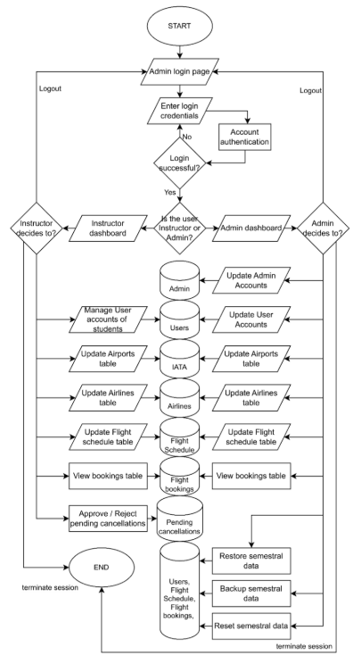

Entity Relationship Diagram

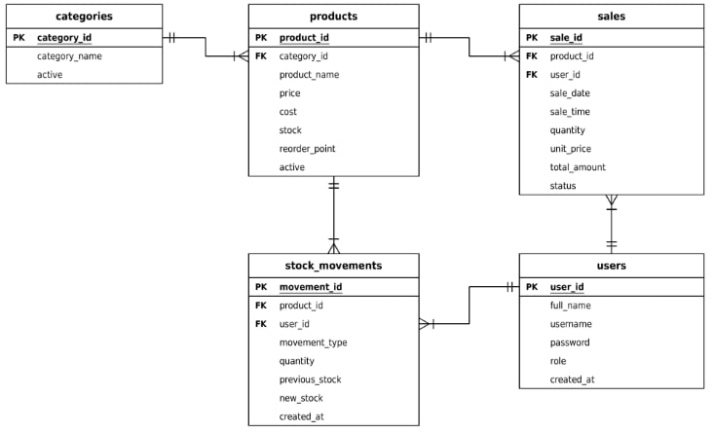

Data Flow Diagram Context Level 0

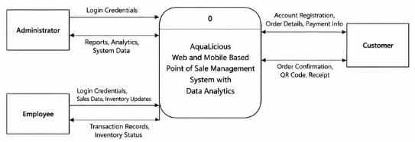

Data Flow Diagram Level 1

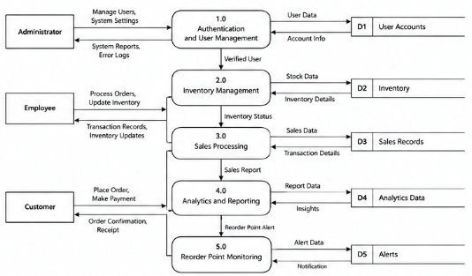

Use Case Diagram

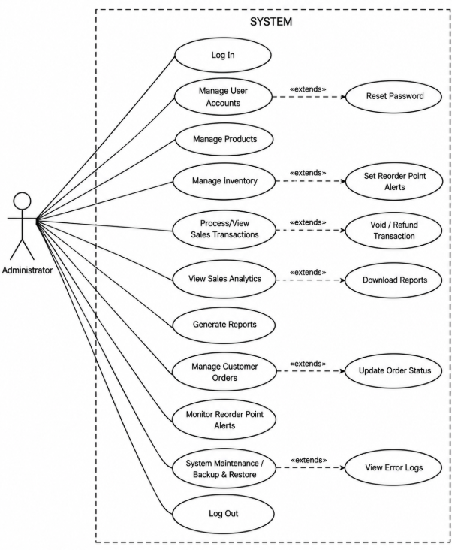

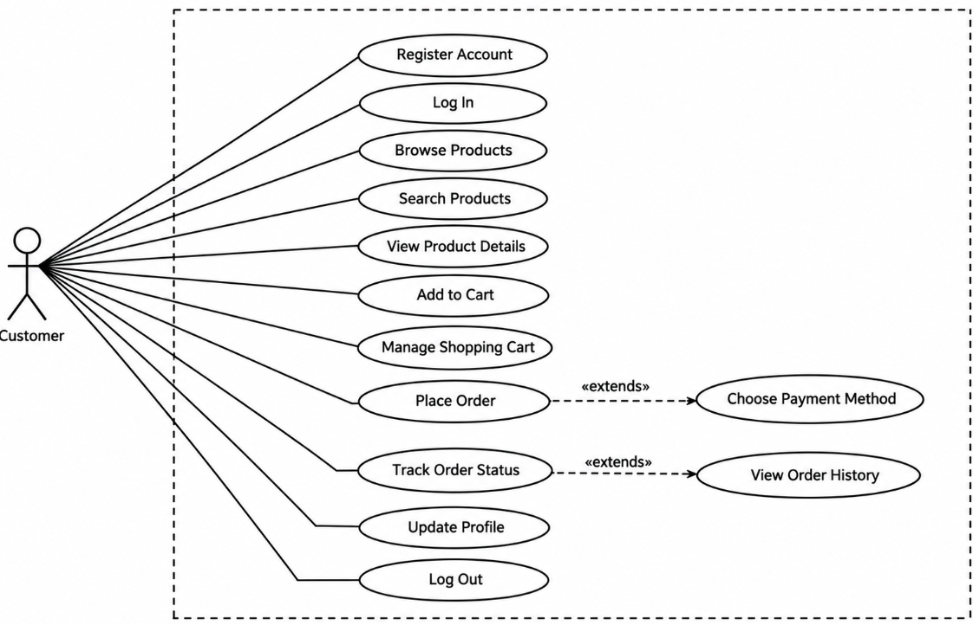

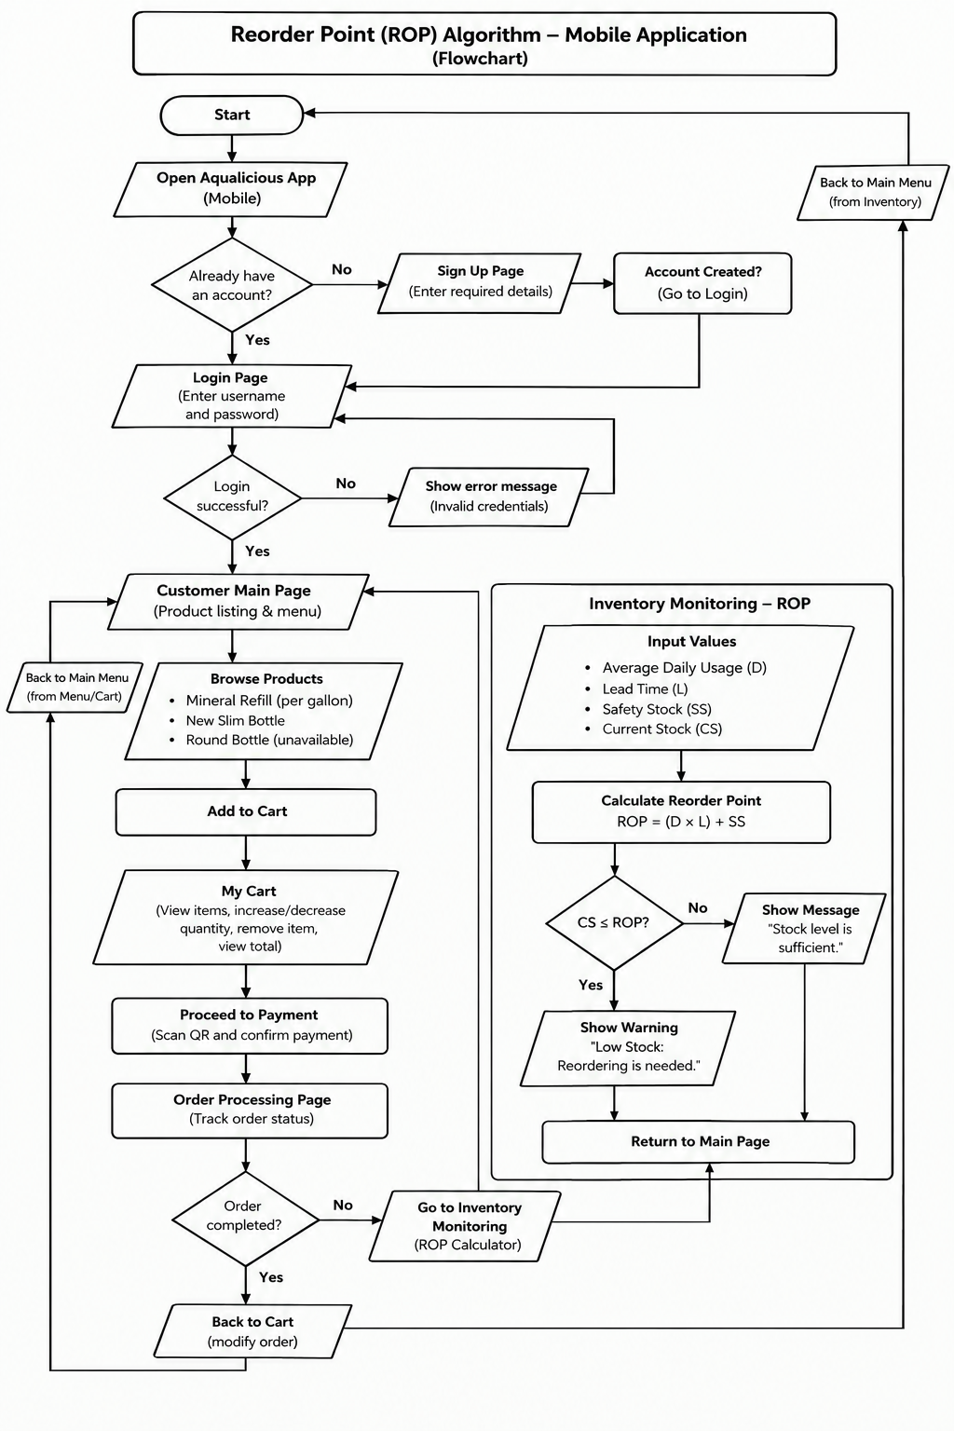

Reorder Point Algorithm Mobile (Inventory Monitoring)
The researchers used the Reorder Point (ROP) Algorithm to track product inventory in the AquaLicious Water Refilling Station's Point of Sale (POS) Management System. The algorithm determines the minimum stock level that will cause a replenishment alert based on average daily usage, supplier lead time, and safety stock. The reorder point is calculated with the formula ROP = (Average Daily Usage × Lead Time) + Safety Stock. When the current stock level reaches or falls below the calculated reorder point, the system flags the product as low inventory and notifies the administrator. This helps the business monitor inventory levels, plan product replenishment, and reduce the risk of stockouts. The algorithm also calculates a recommended order quantity to support inventory replenishment decisions.
class ROPCalculator {
static double calculateROP({
required double averageDailyUsage,
required double leadTimeDays,
required double safetyStock,
}) {
return (averageDailyUsage * leadTimeDays) + safetyStock;
}

static bool needsReordering({
required double currentStock,
required double reorderPoint,
}) {
return currentStock <= reorderPoint;
}
}

Sales Trend Analysis Algorithm
The researchers used the Sales Trend Analysis algorithm in the Reports module to determine whether the business is performing well. The algorithm combines three techniques: the Simple Moving Average, Linear Regression, and Period Comparison. First, the system collects the sales in the selected period, excluding voided transactions, and totals the revenue for each day. Days with no sales are counted as zero so that the line is continuous.
Second, the system applies the Simple Moving Average (SMA) to smooth the daily revenue. For each day, it computes the average revenue of the most recent seven days. Daily sales can rise and fall sharply, so the moving average reduces this short-term noise and makes the overall pattern easier to see (Saleh & Haikal, 2013).
Third, the system applies Linear Regression to draw the trend line. It uses the least squares method to fit a straight line through the daily revenue values. The slope of the line is computed as the sum of (x − x̄)(y − ȳ) divided by the sum of (x − x̄)², where x is the day number and y is the revenue. A positive slope shows that sales are generally increasing over time, while a negative slope shows that they are decreasing (Yoga Winanda et al., 2023).
Finally, the system applies Period Comparison to produce the result shown to the owner. It divides the selected period into an earlier half and a recent half and compares their total revenue. The percentage change is computed as the recent revenue minus the earlier revenue, divided by the earlier revenue, multiplied by 100 (Franklin et al., 2022). A change of +5% or more is classified as “Growing,” a change of −5% or less is classified as “Declining,” and any value in between is classified as “Stable.” The 5% threshold was set by the researchers as a practical cut-off. The daily revenue, the 7-day average, and the trend line are displayed together on a line graph so that the owner can see both the pattern and the result.
<!DOCTYPE html>
<html lang="en">
<head>
<meta charset="UTF-8"/><meta name="viewport" content="width=device-width,initial-scale=1.0"/>
<title>Sales – AquaLicious Admin</title>
<link rel="preconnect" href="https://fonts.googleapis.com"/>
<link href="https://fonts.googleapis.com/css2?family=Poppins:wght@300;400;500;600;700&family=Playfair+Display:wght@600&display=swap" rel="stylesheet"/>
<link rel="stylesheet" href="../css/shared.css"/>
</head>
<body>
<div class="layout">
<div class="main">
<div class="page-content">

<!-- STAT ROW -->
<div class="stat-grid" id="salesStats"></div>

<!-- TOOLBAR -->
<div class="toolbar">
<div class="search-wrap">
<svg viewBox="0 0 24 24" fill="currentColor"><path d="M15.5 14h-.79l-.28-.27A6.471 6.471 0 0 0 16 9.5 6.5 6.5 0 1 0 9.5 16c1.61 0 3.09-.59 4.23-1.57l.27.28v.79l5 4.99L20.49 19l-4.99-5zm-6 0C7.01 14 5 11.99 5 9.5S7.01 5 9.5 5 14 7.01 14 9.5 11.99 14 9.5 14z"/></svg>
<input class="search-input" type="text" placeholder="Search by product or ID…" id="searchInput" oninput="renderTable()"/>
</div>
<input type="date" class="form-control" id="dateFilter" style="width:170px" onchange="renderTable()"/>
<button class="btn btn-outline" onclick="clearFilters()">Clear</button>
<button class="btn btn-primary" onclick="openModal()">+ New Sale</button>
</div>

<!-- TABLE -->
<div class="card">
<div class="card-header">
<span class="card-title">🧾 Sales Transactions</span>
<span id="countLabel" style="font-size:.8rem;color:var(--gray-500)"></span>
</div>
<div style="overflow-x:auto">
<table>
<thead><tr>
<th>ID</th><th>Date</th><th>Time</th><th>Product</th><th>Qty</th><th>Unit Price</th><th>Total</th><th>Status</th><th>Actions</th>
</tr></thead>
<tbody id="tableBody"></tbody>
</table>
</div>
</div>
</div>
</div>
</div>

<!-- NEW SALE MODAL -->
<div class="modal-overlay" id="modalOverlay">
<div class="modal" style="max-width:480px">
<div class="modal-header">
<span class="modal-title">Record New Sale</span>
<button class="modal-close" onclick="closeModal()">✕</button>
</div>
<div class="form-group">
<label class="form-label">Product *</label>
<select class="form-control" id="fProduct" onchange="fillPrice()">
<option value="">Select product…</option>
</select>
</div>
<div class="form-row">
<div class="form-group">
<label class="form-label">Quantity *</label>
<input class="form-control" type="number" id="fQty" value="1" min="1" oninput="calcTotal()"/>
</div>
<div class="form-group">
<label class="form-label">Unit Price (₱)</label>
<input class="form-control" type="number" id="fPrice" placeholder="0.00" oninput="calcTotal()"/>
</div>
</div>
<div class="form-group">
<label class="form-label">Total Amount</label>
<input class="form-control" id="fTotal" readonly style="background:var(--blue-pale);font-weight:700;color:var(--blue-deep)"/>
</div>
<div class="form-group">
<label class="form-label">Date</label>
<input class="form-control" type="date" id="fDate"/>
</div>
<div style="display:flex;gap:.75rem;justify-content:flex-end;margin-top:.5rem">
<button class="btn btn-outline" onclick="closeModal()">Cancel</button>
<button class="btn btn-primary" onclick="saveSale()">Record Sale</button>
</div>
</div>
</div>

<script src="../js/shared.js"></script>
<script>
const PER_PAGE = 12;
let curPage = 1;

function renderStats() {
const sales = Store.activeSales();
const today = localYMD();
const todayS = sales.filter(s=>s.date===today);
const totalR = sales.reduce((a,s)=>a+s.total,0);
const todayR = todayS.reduce((a,s)=>a+s.total,0);
const avgTx = sales.length ? (totalR/sales.length).toFixed(2) : 0;
document.getElementById('salesStats').innerHTML = `
<div class="stat-card"><div class="stat-label">Today's Sales</div><div class="stat-value">${todayS.length}</div><div class="stat-sub">₱${todayR.toLocaleString()} revenue</div><div class="stat-icon icon-blue"><svg viewBox="0 0 24 24" fill="currentColor"><path d="M19 3H5c-1.11 0-2 .9-2 2v14c0 1.1.89 2 2 2h14c1.11 0 2-.9 2-2V5c0-1.1-.89-2-2-2z"/></svg></div></div>
<div class="stat-card"><div class="stat-label">Total Transactions</div><div class="stat-value">${sales.length}</div><div class="stat-sub">All time</div><div class="stat-icon icon-green"><svg viewBox="0 0 24 24" fill="currentColor"><path d="M9 16.17L4.83 12l-1.42 1.41L9 19 21 7l-1.41-1.41z"/></svg></div></div>
<div class="stat-card"><div class="stat-label">Total Revenue</div><div class="stat-value">₱${totalR.toLocaleString()}</div><div class="stat-sub">Lifetime</div><div class="stat-icon icon-orange"><svg viewBox="0 0 24 24" fill="currentColor"><text x="12" y="18.5" text-anchor="middle" font-size="19" font-weight="700" font-family="Poppins,Arial,sans-serif">₱</text></svg></div></div>
<div class="stat-card"><div class="stat-label">Avg Transaction</div><div class="stat-value">₱${parseFloat(avgTx).toLocaleString()}</div><div class="stat-sub">Per sale</div><div class="stat-icon icon-blue"><svg viewBox="0 0 24 24" fill="currentColor"><path d="M3.5 18.49l6-6.01 4 4L22 6.92l-1.41-1.41-7.09 7.97-4-4L2 16.99z"/></svg></div></div>`;
}

function getFiltered() {
const search = (document.getElementById('searchInput').value||'').toLowerCase();
const date = document.getElementById('dateFilter').value;
return Store.sales().filter(s =>
(!date || s.date===date) &&
(!search || s.productName.toLowerCase().includes(search) || String(s.id).includes(search))
).reverse();
}

function renderTable() {
const filtered = getFiltered();
const total = filtered.length;
const pages = Math.ceil(total/PER_PAGE)||1;
if (curPage > pages) curPage=1;
const slice = filtered.slice((curPage-1)*PER_PAGE, curPage*PER_PAGE);
document.getElementById('countLabel').textContent = `${total} record(s)`;
const tbody = document.getElementById('tableBody');
if (!slice.length) {
tbody.innerHTML = `<tr><td colspan="9"><div class="empty-state"><p>No transactions found.</p></div></td></tr>`;
return;
}
tbody.innerHTML = slice.map(s => `<tr class="${s.status==='Voided'?'voided':''}">
<td>#${String(s.id).padStart(4,'0')}</td>
<td>${s.date}</td>
<td>${s.time||'—'}</td>
<td>${s.productName}</td>
<td>${s.qty}</td>
<td>₱${s.unitPrice}</td>
<td><strong>₱${s.total.toLocaleString()}</strong></td>
<td><span class="badge ${s.status==='Voided'?'badge-danger':'badge-success'}">${s.status}</span></td>
<td>${s.status==='Voided' ? '—' : `<button class="btn btn-danger btn-sm" onclick="voidSale(${s.id})">Void</button>`}</td>
</tr>`).join('');
}

function clearFilters() {
document.getElementById('searchInput').value='';
document.getElementById('dateFilter').value='';
renderTable();
}

function voidSale(id) {
if (!confirm2('Void this transaction? The stock will be returned to inventory.')) return;
const sales = Store.sales();
const sale = sales.find(s => s.id === id);
if (!sale || sale.status === 'Voided') return;
sale.status = 'Voided';
Store.saveSales(sales);
// return stock
const prods = Store.products();
const p = prods.find(x => x.id === sale.productId);
if (p) { p.stock += sale.qty; Store.saveProducts(prods); }
toast('Transaction voided. Stock restored.'); renderStats(); renderTable();
}

function openModal() {
const prods = Store.products();
const sel = document.getElementById('fProduct');
sel.innerHTML = '<option value="">Select product…</option>' +
prods.map(p=>`<option value="${p.id}" data-price="${p.price}">${p.name} (₱${p.price})</option>`).join('');
document.getElementById('fQty').value=1;
document.getElementById('fPrice').value='';
document.getElementById('fTotal').value='';
document.getElementById('fDate').value=localYMD();
document.getElementById('modalOverlay').classList.add('active');
}
function closeModal() { document.getElementById('modalOverlay').classList.remove('active'); }
function fillPrice() {
const opt = document.getElementById('fProduct').selectedOptions[0];
if (opt&&opt.dataset.price) { document.getElementById('fPrice').value=opt.dataset.price; calcTotal(); }
}
function calcTotal() {
const q=parseInt(document.getElementById('fQty').value)||0;
const p=parseFloat(document.getElementById('fPrice').value)||0;
document.getElementById('fTotal').value=`₱${(q*p).toFixed(2)}`;
}
function saveSale() {
const prodId = parseInt(document.getElementById('fProduct').value);
const qty = parseInt(document.getElementById('fQty').value);
const price = parseFloat(document.getElementById('fPrice').value);
const date = document.getElementById('fDate').value;
if (!prodId||!qty||!price||!date) { alert('Fill all fields.'); return; }
const prod = Store.products().find(p=>p.id===prodId);
if (!prod) { alert('Product not found.'); return; }
if (prod.stock < qty) { alert(`Insufficient stock! Only ${prod.stock} left.`); return; }
const sales = Store.sales();
const now = new Date();
sales.push({
id: Store.nextId(sales), date, qty,
time: `${now.getHours()}:${String(now.getMinutes()).padStart(2,'0')}`,
productId:prod.id, productName:prod.name, unitPrice:price, total:price*qty,
customer:'Walk-in', status:'Completed'
});
Store.saveSales(sales);
// deduct stock
const prods = Store.products();
prods.find(p=>p.id===prodId).stock -= qty;
Store.saveProducts(prods);
toast('Sale recorded!'); closeModal(); renderStats(); renderTable();
}

document.addEventListener('DOMContentLoaded', () => { renderStats(); renderTable(); });
</script>
</body>
</html>

Research Design
This study used a Descriptive Research Design to examine the sales and inventory management practices at the AquaLicious Water Refilling Station. The goal was to understand the problems that come with using processes. This design helped the researchers see the difficulties that the business owner and employees faced. They used interviews, observations and data collection to learn more (Creswell & Creswell 2023).
The descriptive part of the study looked at how sales were recorded, how inventory was monitored and how business reports were made at AquaLicious Water Refilling Station. Through interviews, observations and data collection the problems that the business owner and employees faced were identified. These problems were studied to find out what the system needed to make the business run better.
A quantitative method was used to check the quality and acceptability of the web and mobile-based Point of Sale (POS) Management System with Data Analytics. A structured survey questionnaire was used for this purpose. The ISO/IEC 25010 Software Quality Model's quality attributes were used by the testers to rate the system. Suitability, performance efficiency, compatibility, interaction, dependability, security, maintainability, and flexibility are some of these attributes. A five-point Likert scale was used to evaluate their responses. Descriptive statistics, especially the arithmetic mean, were used in the analysis to assess the system's acceptability and quality.
The descriptive research design and quantitative method helped the researchers identify the problems that the AquaLicious Water Refilling Station faced. They also checked whether the new system addressed these problems. Features such as sales recording, inventory tracking, synchronization between the web and Android applications and data analytics for examining sales trends, product performance and stock levels were added based on the identified needs. By analyzing the users' responses, the researchers could assess the system's quality and acceptability. Identify areas where it could be improved.
System Development Methodology
A system development methodology provides an organized process for planning, creating, testing and improving an information system. In this study the Agile Software Development Methodology was adopted as the framework for developing the Web and Mobile Based Point of Sale Management System for AquaLicious Water Refilling Station with Data Analytics. Alsaqqa et al. (2020) Discussed Agile methodologies and their applications in software development highlighting approaches that support flexibility and adaptability. Agile principles are appropriate for the proposed system because Agile allows adjustment of system features according to the requirements of the business owner and employees.
Agile supports a development process that allows changes to be made as a project progresses. Stated by Beck (2001) The Manifesto for Agile Software Development emphasizes collaboration, working software. Responding to changing requirements. The AquaLicious POS system benefits from Agile because the development of its web-based application and Android mobile application may require adjustments throughout the development process. Adjustments can help the AquaLicious team address issues. Improve sales recording, inventory management, data synchronization, reporting and data analytics features.
Agile supports iterative development, where system features are developed tested, evaluated and improved through repeated cycles. Mumtaz et al. (2022) Examined the causes, effects and timing of iteration in the software development life cycle highlighting its role in software development. Radack (2009) discussed the Software Development Life Cycle (SDLC) as a framework for guiding the development and implementation of information systems. These concepts are relevant, to the AquaLicious system because different components of the AquaLicious system must be evaluated and refined to ensure that they function according to the identified requirements.
In developing the AquaLicious POS management system the AquaLicious team adopted Agile to support development, testing and improvement. The development process was organized into six stages: planning, design, development, testing, deployment, and review and iteration. Through these stages the AquaLicious team can identify system requirements, design and develop applications evaluate their functions and correct identified problems. This approach allows the AquaLicious team to improve sales transaction recording, inventory management, data synchronization, reporting and data analytics throughout the development process ensuring that the AquaLicious system addresses the needs of the AquaLicious Water Refilling Station.
The Agile methodology focuses on people and their ability to be flexible in responding to changing needs and requirements. Beck et al. (2001) mentioned that the Manifesto for Agile Software Development is centered around people and, more specifically, collaboration. For AquaLicious, the focus is primarily on the business application side. However, Agile is also applicable to the Android mobile application. As pointed out by Alsaqqa et al. (2020), the principles of Agile support flexibility and adaptability, thus allowing for changes to the system and its features, as well as its parameters, during the development process.
Additionally, Agile methodology allows the development process to be repeated and, consequently, helps system features to be repeated, cycled, and integrated through iterative processes. The cycles focus on development, testing, and improving system features. Iterative processes are good models to align with the development and deployment of modern information systems (IS) (Mumtaz et al., 2022). Radack (2009) discussed the SDLC and several frameworks to guide the development and implementation of IS, of which the Agile methodology is a part. The following concepts are relevant to the proposed system because the components of the system must be analyzed and improved to ensure they perform the required functions.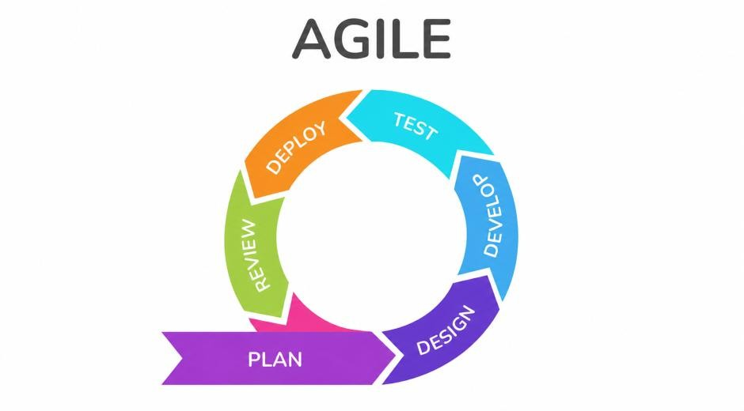
Figure 2. Agile System Development Life Cycle
Figure 2 illustrates the Agile System Development Life Cycle adopted for the proposed POS system. The model presents the six phases followed by the researchers in developing, implementing, and improving the system.
The model presents the six phases followed by the researchers in developing, implementing, and improving the system.
Planning Phase – During the planning phase, the researchers identified the objectives, scope, and functional requirements of the system. Through interviews, discussions, and data gathering with the owner and employees of AquaLicious Water Refilling Station, the researchers determined the requirements for automated sales recording, inventory monitoring, sales reporting, and user access management. These requirements served as the basis for identifying the system's essential features.
Design Phase – During the design phase, the researchers prepared the system architecture, database structure, business process flows, and user interface designs. The system was designed as a web-based application for the administrator and an Android mobile application for employees. The database was structured to organize sales records, product information, inventory levels, and transaction history. The interface designs were also prepared to support ease of use and efficient navigation across both applications.
Development Phase – During the development phase, the researchers implemented the system functionalities incrementally. The development activities were organized into five sprints, with each sprint focusing on specific system components.
Sprint 1: User Authentication and Access Control – Development of login functionality and access permissions for administrators and employees.
Sprint 2: Sales Transaction Processing – Implementation of sales recording and receipt generation.
Sprint 3: Inventory Management – Development of product management, stock monitoring, and automatic inventory updates.
Sprint 4: Reporting and Data Analytics – The development of sales and inventory reports; analysis of sales trends and identification of best-selling and peak-period items; and sales forecasting.
Sprint 5: Web and Mobile Integration – Integration of the web-based administrative application and Android mobile application for data synchronization. Each module was developed in accordance with the system requirements and was prepared for testing and integration with other system components.
Testing Phase – The researchers evaluated the developed system and its components during this phase. They tested individual features by performing unit tests and integrated features by performing integration tests. They also performed tests to check the system’s module integration for sales processing and inventory updates and the synchronization of the web application with the mobile application. User acceptance testing was performed by selected users to check the system’s functionality and usability. The tests revealed errors, which the researchers considered as enhancements.
Deployment Phase – During this phase, the research team configured the system for its intended use at AquaLicious Water Refilling Station. The web application was configured for use via a web server, and the Android application was configured for installation on employees’ Android devices. The team also checked the system configuration and the database connection to ensure that the applications were ready to be used for business operations.
Review and Iteration Phase – During the review and iteration phase, the researchers gathered feedback from the business owner and employees to identify issues and areas for improvement. The feedback and testing results were used to refine system features, improve usability, and correct identified errors. Necessary changes were then implemented and tested again to determine whether the improvements addressed the identified issues. This process supported the continuous refinement of the system according to the operational needs of the AquaLicious Water Refilling Station.
The proposed POS system can be developed in a flexible and organized manner by using the Agile Software Development Methodology. The researchers may develop the web and Android applications' functionality and integration through iterative development, system testing, and user feedback. This procedure aids in the development of a point-of-sale system that meets AquaLicious Water Refilling Station's needs of data analytics, inventory control, reporting, and sales recording.

Participants
This study involved 10 participants who were selected based on their relevance to the evaluation and validation of the Web and Mobile-Based Point of Sale Management System for AquaLicious Water Refilling Station with Data Analytics. The respondents were categorized into distinct groups to ensure a comprehensive assessment of the system in terms of usability, and operational effectiveness.
The business owner was included as the primary administrator of the system, given that they are the key decision-maker and the individual most affected by the operational challenges of the current manual recording practices at AquaLicious Water Refilling Station. Their participation is essential in evaluating whether the system effectively addresses the identified problems in sales transaction recording, inventory management, and data-driven business analysis.
The store employees and customers were selected as end-users of the mobile component of the system, as they are directly responsible for recording daily transactions and monitoring stock levels. Their participation is crucial in evaluating the system's usability, ease of use, and efficiency in streamlining daily tasks while minimizing human errors commonly associated with manual record-keeping.
This study utilized purposive sampling, a non-probability sampling technique wherein participants are intentionally selected based on their direct relevance, experience, and roles related to the research objectives. This approach is particularly appropriate for system development studies that require evaluation from specific individuals who have firsthand knowledge of the operational processes being addressed or the technical expertise needed to assess software quality. In this study, purposive sampling was applied across all three participant groups: the business owner, store employees, and IT experts.
Purposive sampling is employed in this research due to the nature of the proposed system, which is a web and mobile-based Point of Sale management system designed specifically for AquaLicious Water Refilling Station. The system addresses operational problems unique to this business, including inaccurate manual sales recording and disorganized inventory management. Because of this, the evaluation of the system requires individuals who are directly involved in the daily operations of AquaLicious or who possess the technical knowledge to assess the system's compliance with software quality standards.
The use of purposive sampling allows the researchers to obtain highly relevant and reliable evaluation data, as the selected respondents are capable of providing informed feedback based on their actual roles and experiences. The business owner and employees can assess the system's practical utility and usability from an operational standpoint.
. This combination ensures that the system evaluation covers both the end-user perspective and the technical perspective, resulting in a more comprehensive and credible assessment.
This approach is supported by Creswell and Creswell (2023), who noted that purposive sampling is appropriate in developmental and applied research where the goal is to gather targeted information from individuals who are most knowledgeable about the subject being studied. Since the proposed POS system is intended to address specific operational challenges within AquaLicious Water Refilling Station, it is necessary that the respondents are those who are directly affected by or technically qualified to evaluate these challenges.
Furthermore, purposive sampling strengthens the credibility of the study by ensuring that the data gathered reflects the actual needs, experiences, and expert judgments of the intended users and evaluators. Since the system aims to improve the efficiency and accuracy of sales and inventory management, it is essential that the respondents can provide meaningful and context-specific feedback. This ensures that the evaluation results are both valid and useful for further system improvement.
In this study, purposive sampling will be implemented by selecting the business owner and store employees of AquaLicious Water Refilling Station as end-user respondents.

Procedure
These are the information that will assist the researchers to determine the need for the study. The information will be collected using Survey and Questionnaire from the owner of AquaLicious.
- Initial Survey – The researchers will use this initial survey to identify the needs, problems, and preferences relevant to the scope, objectives, and limitations of the study. Interviews were conducted with the business owner of AquaLicious Water Refilling Station during the planning phase of the system development. This initial survey was conducted online through the use of Google Forms to collect data from the owner regarding their experiences and challenges with tallying and doing inventory manually (See Appendix__). The response from the owner were instrumental in uncovering the specific requirements and difficulties faced by owner during their inventory process, which guided the selection and design of the web and mobile-based features.
- Interview – The researchers ask questions and information that are necessary for the system from the owner of the locale—AquaLicious. This will help the researchers analyze the needed data.
- Library Research – The researchers will use their own perception for gathering the data and information. The purpose of this observation is to observe how the system will help the owner of the water refilling station.
- Web Research – The researchers will use the internet to gather information about the study on how they develop systems. The internet will help find related literatures and studies that will support their own research.
- Evaluation Questionnaire – Evaluation serves as a systematic approach for assessing projects using established criteria and standards to determine their quality and value. In this study, the ISO/IEC 25010 software quality model was utilized as the basis for evaluating the system. The evaluation was administered to the owner of AquaLicious who serve as the primary user of the system, as well as 1 IT expert who assessed the system’s technical and quality-related aspects based on the given criteria. For non-IT respondents, the evaluation focused on these key criteria: Functional Suitability, Usability, Reliability, Performance Efficiency, and Security. For IT expert, the evaluation utilized the following criteria:
- Compatibility: Examines if the application operates smoothly from different environment and devices.
- Functional Suitability: Assesses whether the system fulfills the intended functional requirements.
- Maintainability: How easily the system can be improved, fixed, or updated.
- Performance Efficiency: Calculate how quickly and effectively the application carries out its tasks.
- Portability: Analyze how readily the system can be transferred or used.
- Reliability: Verify whether the system operates consistently and remains stale over time.
- Security: Guarantees users’ data and information are protected from unauthorized access.
- Usability: Evaluates how easy and comfortable the system is.

Data Analysis
The data gathered in this study were analyzed using descriptive statistical techniques, specifically frequency count, percentage, and arithmetic mean. The arithmetic mean is commonly used for measures of central tendencies that provides a single numerical value of a set of quantitative observations (Hurley et al., 2023). These methods were selected because they are appropriate for summarizing and interpreting numerical data derived from Likert-scale survey questionnaires. Descriptive statistics are widely used in quantitative and developmental research to present evaluation findings in a structured and easily comprehensible manner.

User Evaluation Using Likert Scale
To examine the users acceptance of the AquaLicious POS system, participants responded to survey items using a 5-point Likert scale from: Excellent, Very Good, Good, Fair, and Poor in which allowed researchers to quantify user attitudes and perceptions as numerical data for statistical analysis— a common approach in research for measuring opinions and attitudes through structured response options (Rokeman, 2024).
Table 5. Five-Point Likert Rating Scale
Numerical Rating | Description
4.20 – 5.00 | Excellent
3.40 – 4.19 | Very Good
2.60 – 3.39 | Good
1.80 – 2.59 | Fair
1.00 – 1.79 | Poor

Frequency count and percentage were applied to determine how responses were distributed across each survey item for all three participant groups: the business owner, store employees, and IT experts. These measures helped illustrate how often each scale option was selected and the proportion it represents relative to the total number of responses. Through this approach, the researchers were able to identify patterns and trends in the respondents’ feedback regarding the usability, functionality, and overall performance of the Web and Mobile-Based Point of Sale Management System for AquaLicious Water Refilling Station with Data Analytics.
The frequency (f) indicates the times that value appears in the dataset. Having knowledge with these frequencies aids researchers see patterns in user interaction, such as how often the model was rated as: Excellent, Very Good, or Good by tallying responses for each category to summarize their occurrences. Likert-scale are widely applied to quantify attitudes and experiences, as well as analysing response frequencies reveals how often each category was selected (Koo et al., 2025).
The Frequency formula:
x̄ = Σ(f × x) / N
Where:
x̄ refers to the arithmetic mean, f represents the frequency of each response, x denotes the numerical value assigned to each response option (ranging from 1 to 5), and N indicates the total number of respondents.
To obtain an overall assessment of each evaluation criterion, the arithmetic mean was utilized. This method was applied to all criteria aligned with the ISO/IEC 25010 Software Quality Model, including functional suitability, usability, performance efficiency, security, maintainability, compatibility, and portability. The arithmetic mean provides a single numerical value that represents the general response of participants by summing the numerical values of all responses and dividing by the total number of respondents.
The Arithmetic Mean is used to represent the average value of a dataset by dividing the sum of all observations by the total number of values. It is widely used in quantative and system evaluation studies because it provides a clear and interpretable summary of numerical data, particularly for Likert-scale responses and usability assessments (Kaur et al., 2021).
The Arithmetic Mean formula:
Mean = S/N
Where:
S = total sum of all numerical responses
N = total number of respondents
x̄ refers to the arithmetic mean, f represents the frequency of each response, x denotes the numerical value assigned to each response option (ranging from 1 to 5), and N indicates the total number of respondents.
The use of the arithmetic mean is appropriate for analyzing Likert-scale data because it summarizes the central tendency of the respondents’ ratings in a single, easily interpretable value. By assigning a corresponding numerical value to each scale point, the method allows the collective assessment of the system to be expressed and compared across criteria.
To aid in the interpretation of results, the computed mean values were translated into descriptive categories using a predefined scale, as presented in the table below.
Table 6. Likert Scale Interpretation
Numerical Rating | Description
4.50 – 5.00 | Excellent
3.40 – 4.19 | Very Good
2.60 – 3.39 | Good
1.80 – 2.59 | Fair
1.00 – 1.79 | Poor

Based on the interpretation scale, mean values between 4.50 and 5.00 are described as Excellent, indicating a very high level of satisfaction and acceptance of the system. Values within 3.40 to 4.19 are described as Very Good, reflecting positive feedback from the respondents. Scores ranging from 2.60 to 3.39 are described as Good, suggesting good acceptance of the system’s features and performance. Meanwhile, values between 1.80 and 2.59 are described as Fair, indicating that the system has meet the moderate respondents’ expectations in certain areas. Lastly, scores from 1.00 to 1.49 are described as Poor, reflecting a highly negative evaluation of the system.
For the qualitative data gathered through interviews conducted with the business owner during the planning phase of system development, responses were analyzed through thematic grouping and interpretation. Key insights were identified and organized into categories related to operational needs, current challenges in manual sales recording, and inventory management requirements. This approach enabled the researchers to systematically interpret the owner’s feedback and use it as the primary basis for defining the system’s functional requirements, ensuring that the developed POS system directly addresses the specific operational problems of AquaLicious Water Refilling Station.

Design and Implementation
Design is the act of planning and arranging a system. Design sets out the system’s structure, parts, how data moves and how users interact before any coding starts. Design acts as a guide that steers the creation of a system according to its needs and goals. Good design makes sure that the application stays organized works well and fits the people who will use it.
In this study the design of the AquaLicious Web- and Mobile-Based Point of Sale (POS) Management System with Data Analytics was built to help the work of AquaLiciousWater Refilling Station in Angeles City, Pampanga. The design gives a place where sales records, product details and inventory lists can be kept. The design also adds an app that lets customers look at items add them to a cart pay and see how their order is moving. The design further includes a Reorder Point calculator so that the system can show when new stock should arrive using daily use how long it takes to get supplies, from the vendor and a safety buffer.
Implementation is the step where the design of the AquaLicious system turns into a product by writing code building screens and linking all parts together. This phase builds the web POS system and the mobile app exactly as the requirements say. The implementation of the AquaLicious system puts emphasis on handling sales keeping track of stock giving customers a way to order and adding data analytics so that the business can watch its activity and choose actions.
Through these steps the AquaLicious system seeks to make business records clearer make daily sales easier and help inventory be watched efficiently.

Requirement Specification Analysis
Requirement specification analysis is the process of discovering, documenting, and analysing the functional or feasible system features in able to completely produce the set of requirements consistently as well as making sure that it meets the needs of the user and its objectives (Sharma et al., 2018).
In this study, requirement specification analysis was conducted to support the development of a POS system for AquaLicious Water Refilling Station at Barangay Tabun, Angeles City, Pampanga. The system requirements were based from the own and its operational characteristics. Key functional requirements include user registration and login, admin dashboard, products and inventory, data analytics, sales and transaction process, and reorder point notifications. Non-functional requirements focus on usability, reliability, and data security to ensure a safe and effective learning environment.
As noted on these requirements, the POS system enables the admin to manage their inventory real time without the use of manual tally as well as allowing them to analyze their sales through the data analytics of the system. As for the users—it allows them to order online from their phone, without the need to go at store to refill their water. This section therefore presents the key features available to the admins, and end users.
- Login and Registration Module – This module allows administrators and customers to access the system through their respective accounts. Administrators can access management features, while customers can browse available products and place orders.
- Dashboard Module – This module provides different dashboard interfaces for administrators and customers to support their respective activities.
- Admin Dashboard – Displays an overview of the water refilling station’s sales, inventory levels, and transaction records. It also helps administrators monitor stock levels and identify items that need replenishment using the reorder point algorithm.
- Customer Dashboard – Displays available water products and services, allowing customers to browse products, place orders, and make payments through QR code payments.
- Point of Sale (POS) Module – This module manages sales transactions by recording customer orders, calculating total payments, and maintaining transaction records. It helps improve the accuracy and efficiency of sales processing.
- Inventory Management Module – This module allows administrators to add, update, and manage product information and stock quantities. It also monitors inventory levels and uses the reorder point algorithm to identify when stocks need replenishment.
- Order Management Module – This module enables administrators to monitor and manage customer orders and track their status. It also helps ensure that orders are properly recorded and processed.
- Reports and Data Analytics Module – This module generates daily sales reports and provides analytical summaries of sales performance, inventory movement, and transaction records. It helps administrators identify sales trends and make informed business decisions.
- Administration and System Maintenance Module – This module provides authorized administrators with tools to manage system settings, user accounts, and operational records.
- User Account Management – Allows administrators to manage user accounts and access permissions according to their assigned roles.
- Inventory and Transaction Management – Allows administrators to review and update inventory records and manage transaction records when corrections or authorized voids are necessary.
- System Maintenance – Supports the maintenance of system functions and the monitoring of system errors to help ensure reliable operation.
- Data Security and Backup – Supports the protection and backup of inventory records, sales transactions, customer information, and analytics data to help maintain data integrity and availability.

System Design and Specifications
System design and specifications describe how a system will be structured and how its components will operate to satisfy the defined requirements. This phase translates system requirements into technical and architectural details, including platform choice, user interface design, system behavior, and algorithm integration, ensuring that the final system is both functional and user-friendly (Jackson et al., 2025).
In this study, the system design and specifications focus on the development of a web and mobile-based Point of Sale Management System with Data Analytics specifically intended for AquaLicious Water Refilling Station. The system operates through two integrated platforms: a web-based administrative application for the Administrator (business owner) and an Android-based mobile application used by Employees (store staff) to process sales at the station. The mobile application is designed for Android devices only, which are the devices used by the owner and employees of the station. Its user interface emphasizes simplicity and clarity to allow users, including those with limited technical backgrounds, to record transactions, check stock levels, and view reports efficiently and without difficulty.
Both platforms communicate with a centralized MySQL database that stores user accounts, products, transactions, and inventory records, allowing sales, inventory, and customer records to be synchronized in real time. Role-based access control ensures that only the Administrator can manage products, stock, customer data, users, and reports, while Employees are limited to processing sales transactions and checking current stock. Input validation and sanitization also protect the system against unauthorized access and cross-site scripting (XSS) attacks.
The system also integrates the Reorder Point (ROP) Algorithm and the Sales Trend Analytics Algorithm to support data-driven decision-making. The ROP Algorithm computes the reorder point using the formula ROP = (Average Daily Usage × Lead Time) + Safety Stock and notifies the Administrator when stock falls at or below that level. The Sales Trend Analytics Algorithm performs peak period detection, Simple Moving Average (SMA) forecasting based on the previous seven days of sales, and growth rate calculation. Through this design, the business owner can observe how sales and inventory change over time and plan ahead with greater confidence. Overall, the system is designed as a practical tool that replaces the manual notebook-based recording currently used by the station with a faster, more accurate, and more organized process.
User Interface (UI) Design
The User Interface (UI) facilitates interaction between users and the system by providing an accessible and organized platform for navigating its features. It consists of visual elements such as page layouts, color schemes, icons, typography, buttons, and input fields that contribute to the system's overall appearance and functionality. A well-designed user interface improves the user experience by making system features easier to understand and allowing users to perform tasks efficiently. In a management system, an effective UI is essential for ensuring convenient navigation, accurate data entry, and efficient access to important information.
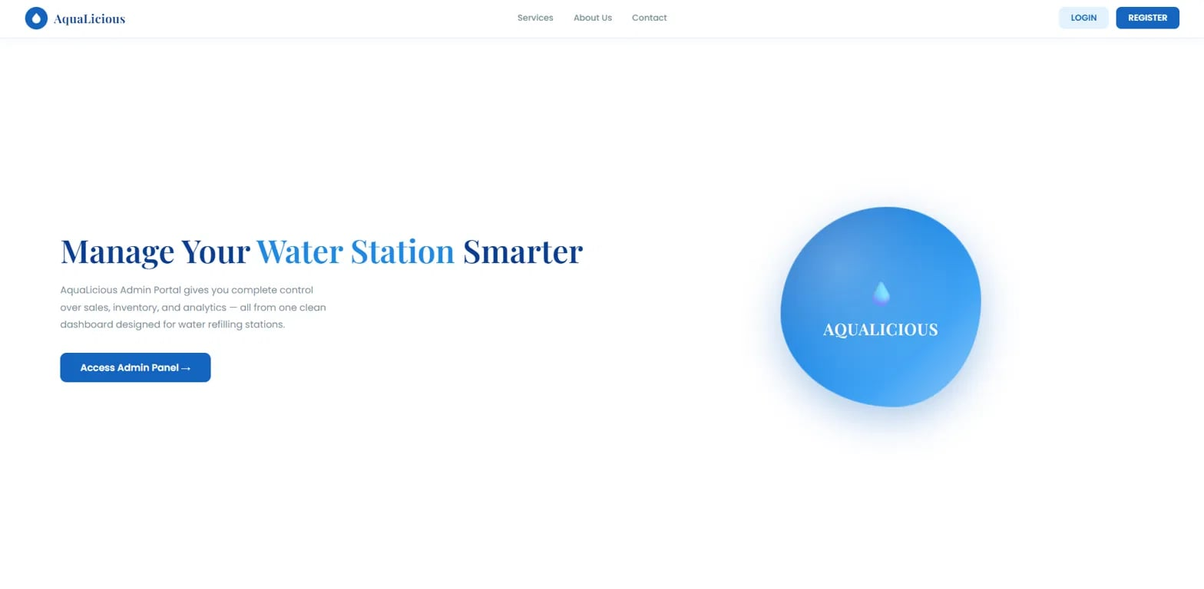
The accompanying interface design illustrates the initial User Interface (UI) of the proponents' system entitled “A Web and Mobile Based Point of Sale Management System for AquaLicious Water Refilling Station with Data Analytics.” The interface features a blue-and-white color scheme that represents cleanliness, freshness, and water. It includes a landing page with login and registration options, allowing authorized users to access the system. The design serves as an entry point to the management platform, which is intended to support sales processing, inventory management, financial reporting, and data analytics. Through its organized layout and accessible interface elements, the system aims to provide a user-friendly experience for managing the daily operations of AquaLicious Water Refilling Station.
Figure 3. End-User Site (Login Page)

The public-facing entry point. It has a navigation bar (Services, About Us, Contact), Login and Register buttons, and a hero section reading “Manage Your Water Station Smarter” with an Access Admin Panel button. This is the gateway into the system and the only module visible before authentication.
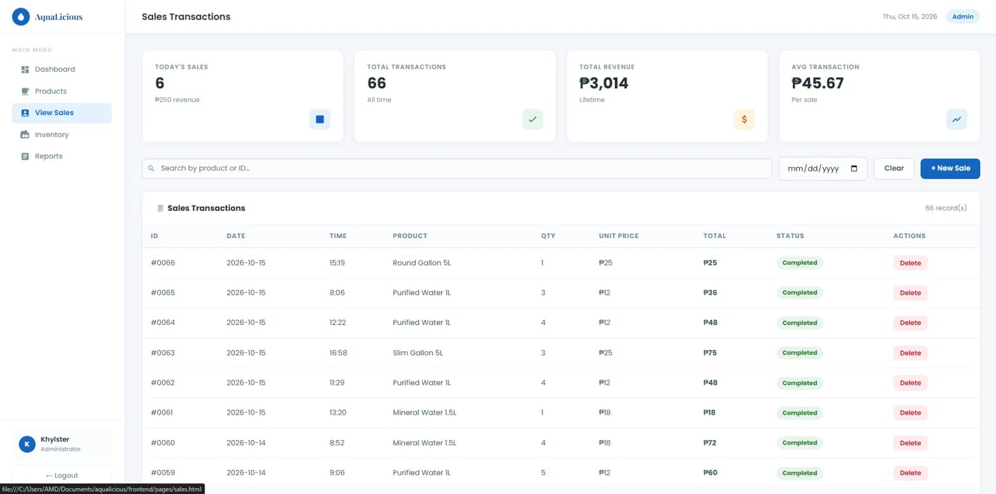
Figure 4. End-User Site (View Sales)
The at-a-glance home screen for admins. It answers “how is the business doing right now?” Four summary cards: Today’s Revenue (₱250 from 6 transactions), Total Sales (66 transactions all-time), Total Products (6, with 2 below reorder point), and Total Revenue (₱3,014 all-time). Sales – Last 7 Days: a bar chart of daily sales, so you can spot which days are strong or weak. ROP Alerts: a warning panel listing products at or below their Reorder Point (Round Gallon 5L at 14 vs. 20, Mineral Water 1.5L at 5 vs. 25). Recent Transactions: the latest sales with ID, date, product, quantity, total, and status, plus a View All link to the full sales list.

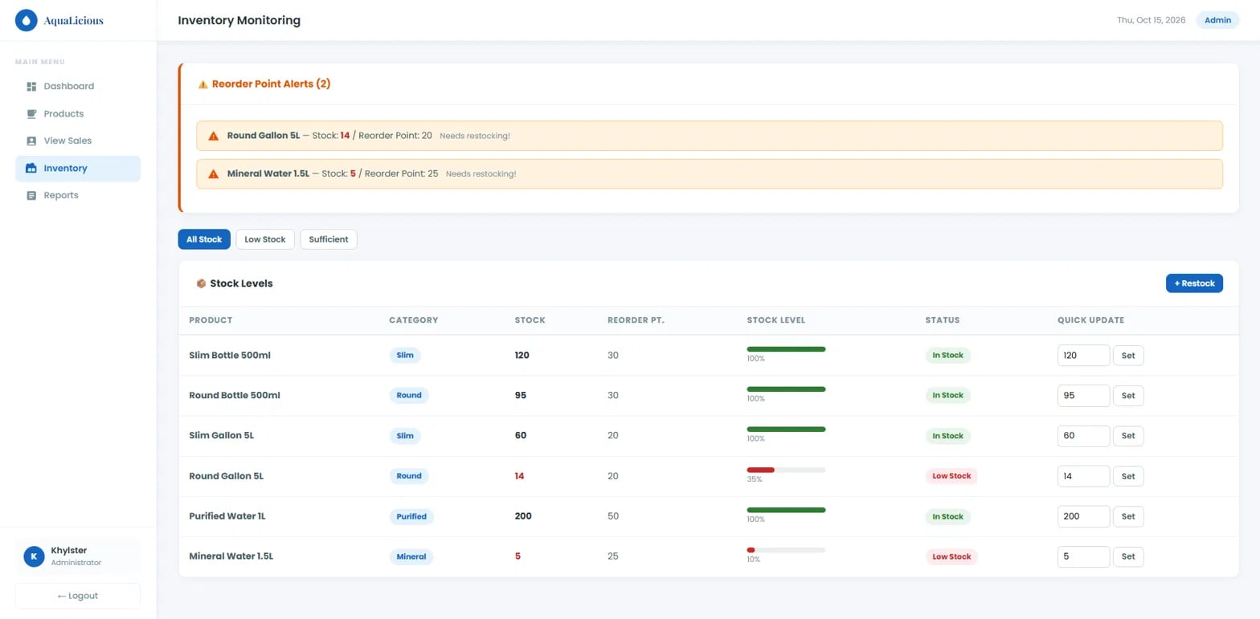
Figure 5. End-User Site (Inventory)
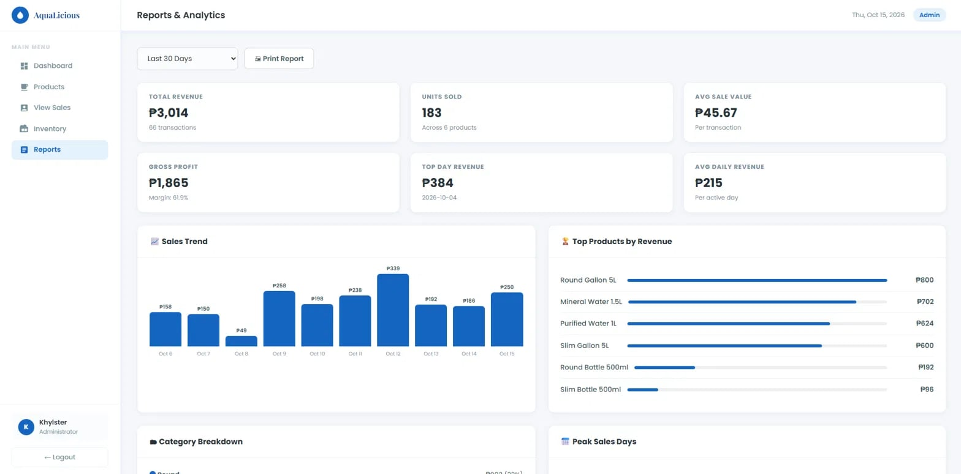
The product catalog, where records are created and maintained (essentially the “master data”). Search bar and category filter to find products quickly. Add Product button to register new items. Product List table with ID, name, category (Slim, Round, Purified, Mineral), selling price, cost, current stock, reorder point, and a status badge (In Stock / Low Stock). Edit and Delete actions on each row. Having both price and cost per product is what makes the profit calculations in Reports possible. For example, a Slim Gallon 5L sells for ₱25 and costs ₱10.

Figure 6. End-User Site (Reports & Analytics)
The point-of-sale record and history of every transaction. Summary cards: Today’s Sales count, Total Transactions, Total Revenue, and Avg Transaction (₱45.67 per sale). Search by product or ID, plus a date filter and Clear button. + New Sale button to record a sale. Transactions table: ID, date, time, product, quantity, unit price, total, status (Completed), and a Delete action. When a sale is recorded, it should reduce the product’s stock. That is what feeds the Inventory module and the reorder alerts.
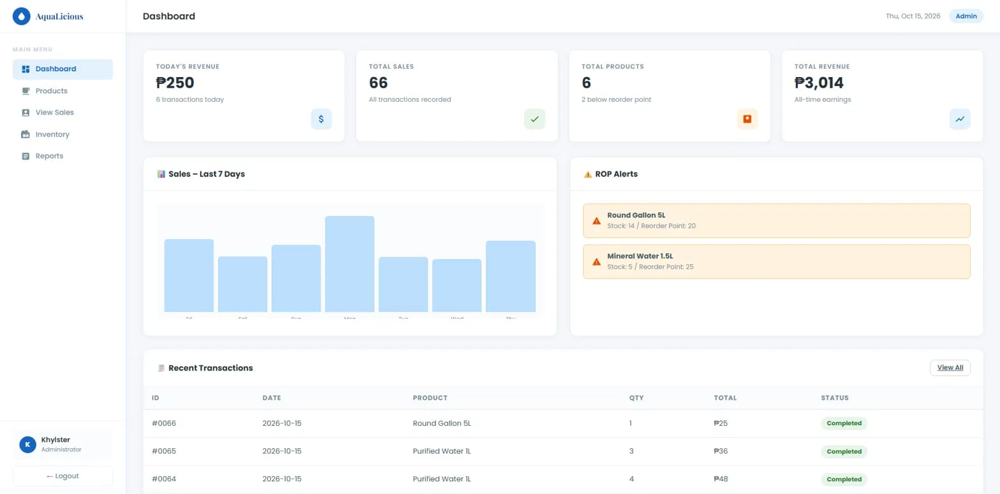
Figure 7. End-User Site (Dashboard)
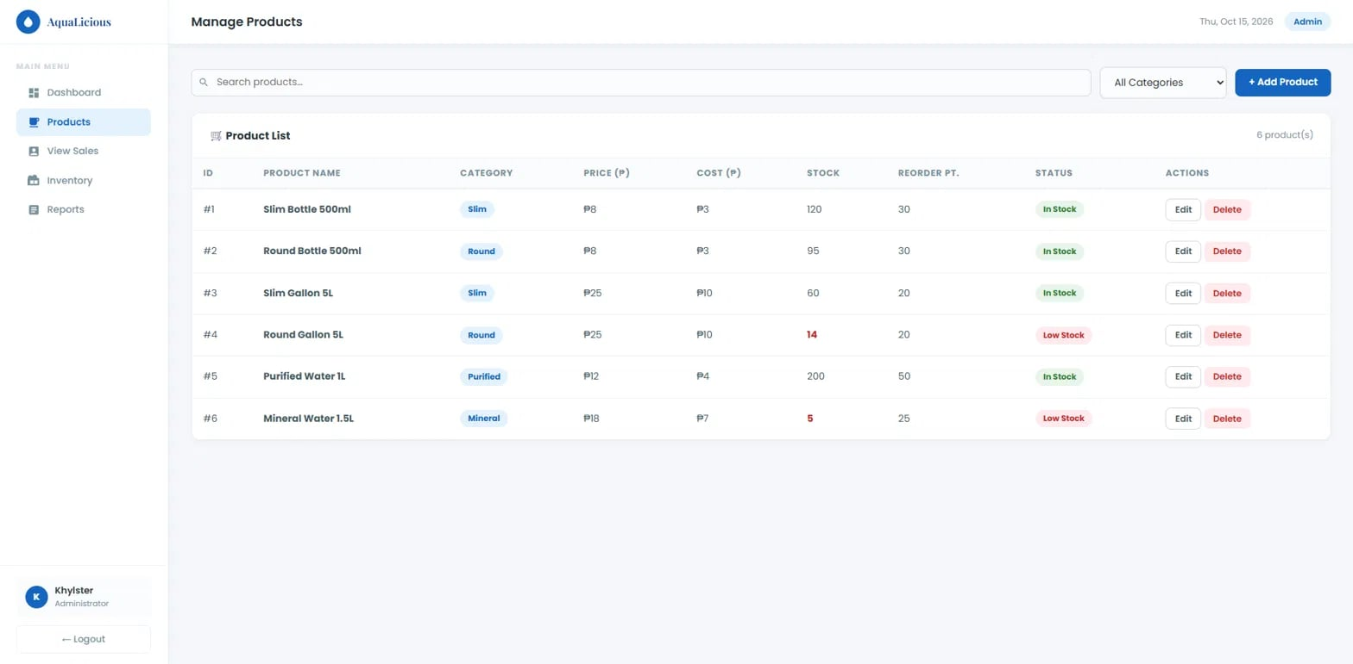
Focused on stock control, so you never run out of what customers buy. Reorder Point Alerts: a highlighted box at the top listing items that need restocking. Filter tabs: All Stock, Low Stock, Sufficient. Stock Levels table: product, category, stock, reorder point, a stock level bar (green when healthy, red when low, with a percentage), and a status badge. Quick Update: type a new quantity and click Set to correct stock directly, which is handy after a physical count. + Restock: records incoming stock. The Reorder Point (ROP) is the stock level at which you should place a new order. When stock falls to or below it, the system flags the item.
Figure 8. End-User Site (Products)
The business intelligence module, used for decision-making. Period selector (e.g., Last 30 Days) and a Print Report button. KPI cards: Total Revenue (₱3,014), Units Sold (183), Avg Sale Value (₱45.67), Gross Profit (₱1,865, a 61.9% margin), Top Day Revenue (₱384 on Oct 4), and Avg Daily Revenue (₱215). Sales Trend: daily revenue bars across the period. Top Products by Revenue: a ranking (Round Gallon 5L leads at ₱800, Slim Bottle 500ml is lowest at ₱96). Category Breakdown: revenue share per category. Peak Sales Days: which days of the week perform best, useful for staffing and stocking. Shared Elements Sidebar navigation linking all modules. Header showing the current date and the user’s role badge (Admin). User panel and Logout at the bottom (logged in as Khylster, Administrator). How the Modules Connect Products defines what you sell, along with prices, costs, and reorder points. View Sales records transactions against those products. Inventory reflects the resulting stock changes and raises alerts. Dashboard summarizes today’s state across all of it. Reports analyzes the history over time for profit and trends.
Mobile User Interface (Design)
The User Interface (UI) serves as the medium through which users interact with the features and functions of a system. It includes visual elements such as screen layouts, color schemes, icons, buttons, and typography that contribute to the system's usability and overall appearance. A well-designed user interface helps users navigate the application, perform tasks efficiently, and access the system's functions with ease.
The accompanying images below present the initial User Interface (UI) design of the proponents' AquaLicious Web- and Mobile-Based Point of Sale (POS) Management System with Data Analytics for AquaLicious Water Refilling Station in Angeles City, Pampanga. The interfaces are designed to support business operations and customer transactions through features for product browsing, shopping cart management, payment processing, order status tracking, and inventory monitoring. The system also incorporates a Reorder Point (ROP) calculator to assist in determining when inventory replenishment is needed, supporting more organized inventory monitoring and efficient daily operations.


Figure 9. Login Page
The image presents the login page of the AquaLicious application. It allows users to access the system by entering their username and password. The page also provides a link for password recovery and an option for new users to proceed to the registration page.

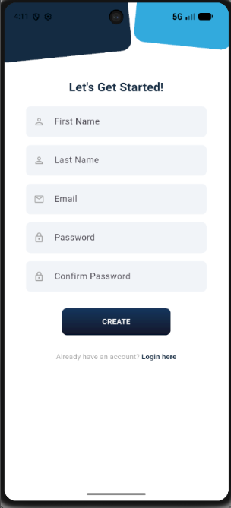
Figure 10. Register Page
The image presents the registration page where new users can create an account for the mobile application by entering their personal credentials. Users are required to input their first name, last name, email address, and establish a secure password with validation confirmation. Upon completing the form, tapping the "CREATE" button submits the data for account provisioning, while existing users can navigate directly to the authentication interface via the "Login here" hyperlink.
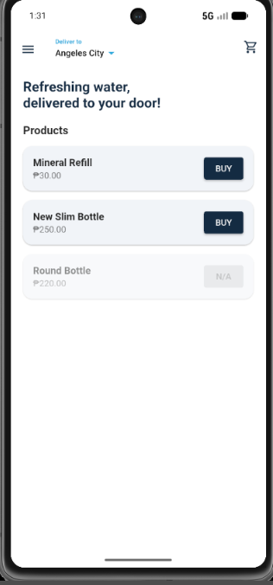
Figure 11. Product Page
The image presents the main product catalog interface of the water delivery mobile application, which allows users to browse available items and manage their delivery details. Users can view the designated delivery location, check product names alongside their respective prices in Philippine Pesos (₱), and see real-time inventory indicators such as out-of-stock statuses marked as "N/A". The page provides direct access to purchasing features through individual "BUY" buttons for active products, a shopping cart shortcut in the upper right corner, and a sidebar navigation menu for account management.
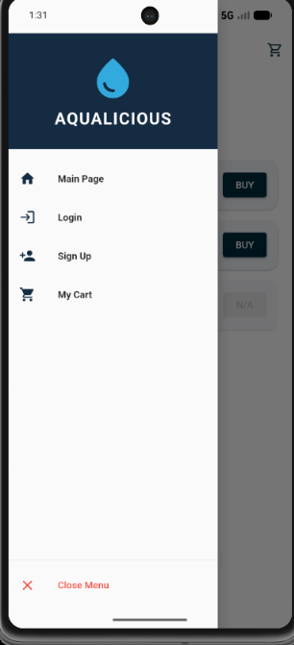

Figure 12. Menu
The image presents the drawer-style navigation sidebar menu of the AQUALICIOUS water delivery mobile application, which provides users with global system navigation pathways. The interface features the official system branding logo at the top header, followed by a vertical menu list paired with intuitive visual icons. Through this panel, users can seamlessly transition between primary sections including the Main Page, Login, Sign Up, and My Cart interfaces, or dismiss the sidebar drawer entirely using the "Close Menu" option positioned at the bottom.
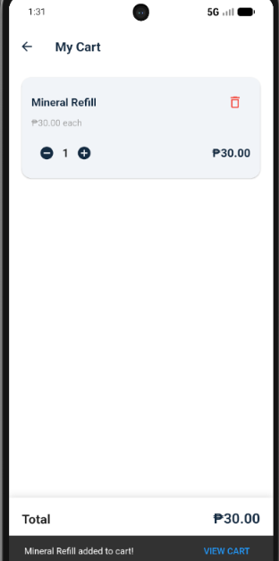

Figure 13. Cart
The image presents the shopping cart interface of the application, which allows users to manage selected items prior to final checkout. The interface displays an itemized list of added products, showcasing the product name, individual unit price, total calculated item cost in Philippine Pesos (₱), and an interactive quantity selector containing increment and decrement controls. Users can modify order quantities, remove items entirely using the trash bin shortcut icon, monitor the cumulative balance via the persistent total summary bar at the footer, or return to the main catalog using the back navigation arrow.

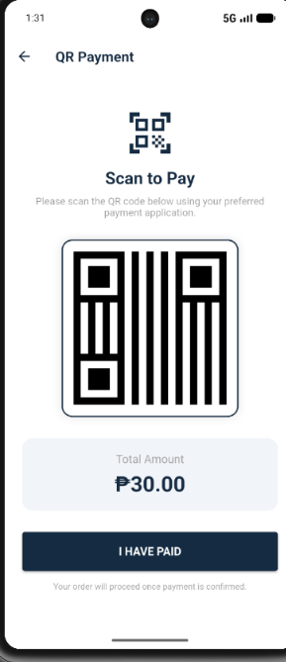

Figure 14. QR Scan
The image presents the digital payment interface of the application, which facilitates cashless transactions through QR code scanning. The page displays a dynamically generated or static quick response (QR) graphic module along with explicit instructions prompting users to scan the code using their preferred external financial or mobile wallet application. The interface clearly states the finalized billing cost under the "Total Amount" field in Philippine Pesos (₱) and provides a primary "I HAVE PAID" confirmation button to notify the system to verify the transaction details and initiate the final order confirmation workflow.

REFERENCES

Alcantara, J. (2023). Business analytics adoption in retail management systems. Cogent Business & Management. https://doi.org/10.1080/23311975.2023.2184512
Andarwati, M., Amrullah, F., Thamrin, E., & Muslikh, A. R. (2020, September). An analysis of point of sales (POS) information systems in SMEs with the black box testing and PIECES method. ResearchGate. https://www.researchgate.net/publication/344336717_An_Analysis_of_Point_of_Sales_POS_Information_Systems_in_SMEswith_The_Black_Box_Testing_and_PIECES_Method
Ardakani, M. F., Ardakani, M. S., & Mirhosseini, H. (2021, May 20). A study about customer satisfaction of e-service quality of point of sale (POS). ResearchGate. https://www.researchgate.net/publication/351710462_A_study_about_customer_satisfaction_of_e-service_quality_of_point_of_sale_POS
Asian Development Bank. (2022). Digitalization of SMEs in Southeast Asia. https://adb.org/publications/digitalization-smes
Ayuns, L., Kayode, O., & Herry, J. (2025, May). Integrating AI with POS systems for real-time inventory management. ResearchGate. https://www.researchgate.net/publication/393140056_Integrating_AI_with_POS_Systems_for_Real-Time_Inventory_Management
Baham, C., & Hirschheim, R. (2022). Issues, challenges, and a proposed theoretical core of agile software development research. Information Systems Journal. https://doi.org/10.1111/isj.12336
Baylen, L. N. L. (2020). Analysis of inventory management systems of selected small-sized restaurants in Quezon Province: Basis for an inventory system manual. Journal of Business and Management Studies, 2(3), 9–18. https://al-kindipublishers.org/index.php/jbms/article/view/852/697
Bienvenido, J. M. T. (2023, August). An assessment of the usability of the centralized point-of-sale (POS) system for inventory management of Bounty Agro Ventures, Inc. rotisserie operation [Bachelor’s thesis, University of the Philippines Los Baños, College of Economics and Management]. University of the Philippines Digital Repository. https://www.ukdr.uplb.edu.ph/etd-undergrad/11821/
Canlas, J., Collado, L., Magundayao, P., Sy, P., & Tumbali, G. (n.d.). The influence of point of sale system in the supply chain performance of the retail sector. http://urdc.usl.edu.ph/papers/abar/abar_vol6_s2019_p1.pdf
Chalmers University of Technology. (2017). Van Acker, S., Hausknecht, D., & Sabelfeld, A. Measuring login webpage security. In Proceedings of the Symposium on Applied Computing (pp. 1753–1760). Association for Computing Machinery. https://doi.org/10.1145/3019612.3019798
Chavez, D., & Tan, K. (2023). Digital transformation in retail: The impact of POS technologies. Sustainability, 15(5), Article 3987. https://www.mdpi.com/2071-1050/15/5/3987
Creswell, J. W., & Creswell, J. D. (2023). Research design: Qualitative, quantitative, and mixed methods approaches (6th ed.). SAGE Publications.
De la Cruz, M. (2022). Barriers to digital technology adoption among Philippine small businesses. Philippine Institute for Development Studies. https://pids.gov.ph/publication/discussion-papers
Department of Trade and Industry. (2023). SME development and digital transformation program. https://dti.gov.ph
Directory of Open Access Journals. (n.d.). [Article record; title and authors need verification]. https://doaj.org/article/9db039db22fd4c15925cd5b29becf310
Ercilla, L., Delos Santos, A., Garcia, J., Gonzales, A., Relano, K., & Portugal, M. E. (2024, September 6). A research proposal of inventory and POS system for Bida Mart in the City of San Jose del Monte, Bulacan. AA Research Index. https://ojs.aaresearchindex.com/index.php/aajmrcp/article/view/12671
Franklin, M., Graybeal, P., Cooper, D., & White, A. (n.d.). Horizontal and vertical analysis. In Accounting and accountability. Pressbooks. https://oer.pressbooks.pub/utsaccounting1/chapter/horizontal-and-vertical-analysis/
Ganepola, G. A. M. U. (2010). A web based inventory management and sales system [Master’s thesis, University of Peradeniya]. University of Peradeniya Institutional Repository. https://ir.lib.pdn.ac.lk/items/c041624a-46dc-493a-b01b-c72f052c9ea4
Google Developers. (2024). Data analytics and visualization tools for business systems. https://developers.google.com
Gonzales, H. (2024). Digital readiness of SMEs in Central Luzon. Philippine Statistics Authority. https://psa.gov.ph/content/sme-digitalization-report
Hidayati, I., Sudarmiatin, S., & Hermawan, A. (2023). Analysis of point of sale system implementation in coffee shop. Jurnal Pendidikan dan Kewirausahaan, 11(3), 932–947. https://doi.org/10.47668/pkwu.v11i3.881
Hidayati, I., Sudarmiatin, S., & Hermawan, A. (2023, June 13). Analysis of point of sale system implementation in coffee shop. ResearchGate. https://www.researchgate.net/publication/372175469_Analysis_of_Point_of_Sale_System_Implementation_in_Coffee_Shop
Hurley, M., & Tenny, S. (2023, July 17). Mean. StatPearls Publishing. https://www.ncbi.nlm.nih.gov/books/NBK546702/
IBM. (n.d.-a). Agile project management. https://www.ibm.com/think/topics/agile-project-management
IBM. (n.d.-b). What is the systems development life cycle (SDLC)? https://www.ibm.com/think/topics/sdlc
International Journal of Retail & Distribution Management. (2023). Retail information systems and technology adoption. Emerald Publishing. https://www.emerald.com/insight/publication/issn/0959-0552
International Organization for Standardization, & International Electrotechnical Commission. (2023). ISO/IEC 25010:2023 systems and software engineering—Systems and software quality requirements and evaluation (SQuaRE)—Product quality model. https://www.iso.org/standard/78176.html
Jan, S. U., Shah, K., & Mand, N. (2023). Point of sale system. SSRN Electronic Journal. https://doi.org/10.2139/ssrn.4368998
Jonathan, L., & Cruz, E. (2024). Cloud and web-based POS technologies for small enterprises. IEEE Xplore. https://ieeexplore.ieee.org/document/10432119
Kabir, A., & Han, B. (2016). An improved usability evaluation model for point-of-sale systems. International Journal of Smart Home, 10(7), 269–282. https://doi.org/10.14257/ijsh.2016.10.7.27
Karhapää, P., Behutiye, W., Seppänen, P., Rodríguez, P., Oivo, M., Franch, X., Martínez-Fernández, S., López, L., Choraś, M., Bagnato, A., Aaramaa, S., & Partanen, J. (2024). Evidence-based quality-aware agile software development process: Design and evaluation. IEEE Access, 12, 86487–86512. https://doi.org/10.1109/ACCESS.2024.3414614
Koo, M., & Yang, S.-W. (2025). Likert-type scale. Encyclopedia, 5(1), 18–18. https://doi.org/10.3390/encyclopedia5010018

Laudon, K., & Laudon, J. (2022). Management information systems: Managing the digital firm. Pearson. https://www.pearson.com/en-us/subject-catalog/p/management-information-systems/P200000003441
Lopez, A., & Martinez, P. (2023). Adoption of web-based point of sale systems in small retail businesses. ScienceDirect. https://www.sciencedirect.com/science/article/pii/S1877050923005121
Mendoza, S., & Santiago, R. (2023). Data-driven decision making in small retail enterprises. SAGE Journals. https://journals.sagepub.com/home/sgo
Mohd Rokeman, N. R. (2024). Likert measurement scale in education and social sciences: Explored and explained. EDUCATUM Journal of Social Sciences, 10(1), 77–88. https://doi.org/10.37134/ejoss.vol10.1.7.2024
Northwestern University, Kellogg School of Management. (2003, July 31). The effect of lead time uncertainty on safety stocks. https://www.kellogg.northwestern.edu/faculty/chopra/htm/research/lead-timejuly31-2003.pdf
Parkan, C. (2003). Measuring the effect of a new point of sale system on the performance of drugstore operations. Computers & Operations Research, 30(5), 729–744. https://doi.org/10.1016/S0305-0548(02)00047-3
Philippine Statistics Authority. (2023). Small and medium enterprises statistics. https://psa.gov.ph
Reyes, J. (2021). Manual accounting practices among small retail enterprises in developing economies. ResearchGate. https://www.researchgate.net/publication/351902615
Rodriguez, L., Ramos, J., & Garcia, P. (2023). Inventory management optimization using POS reporting systems. ScienceDirect. https://www.sciencedirect.com/science/article/pii/S0957417423001124
Saleh, U. A., & Haikal, G. (2013). Transforming the simple moving average forecasting technique into a judgmental bootstrapping approach. AMTP Proceedings 2013. https://doi.org/10.20429/amtp.2013.60
Salha, R. (2021, July 22). Chapter 2 central tendency and variability measures. https://doi.org/10.13140/RG.2.2.22991.20641

Santos, R., & Delos Reyes, M. (2022). The role of small and medium enterprises in local economic development in the Philippines. Philippine E-Journals. https://ejournals.ph/article.php?id=17565
Sebastina Nkechi Okofu, S. N., Asuai, C., Okumoku-Evroro, O., & Maureen, A. (2025). Development of an enhanced point of sales system for retail business in developing countries. 11(5), 1–24. https://doi.org/10.22624/AIMS/BHI/V11N1P1
Sharma, S., & Pandey, S. K. (2018). Revisiting requirement analysis techniques and challenges. In M. Pant, K. Ray, T. K. Sharma, S. Rawat, & A. Bandyopadhyay (Eds.), Soft computing: Theories and applications (Advances in Intelligent Systems and Computing, Vol. 584, pp. 667–678). Springer. https://doi.org/10.1007/978-981-10-5699-4_63
Stair, R., & Reynolds, G. (2020). Principles of information systems. Cengage Learning. https://www.cengage.com/c/principles-of-information-systems
Study of effectiveness of POS data in managing supply chain. (n.d.). ResearchGate. https://www.researchgate.net/publication/328406416_Study_of_Effectiveness_of_POS_Data_in_Managing_Supply_Chain
Tronqued, K. (2026). Point of sale system used by the start-up cafés in Tabaco City, Albay. Journal of Interdisciplinary Perspectives, 4(5), 125–141. https://doi.org/10.69569/jip.2026.128
Turban, E., Pollard, C., & Wood, G. (2021). Information technology for management. Wiley. https://www.wiley.com/en-us/Information+Technology+for+Management-p-9781119702906
Van Acker, S., Hausknecht, D., & Sabelfeld, A. (2017). Measuring login webpage security. In Proceedings of the Symposium on Applied Computing (pp. 1753–1760). Association for Computing Machinery. https://doi.org/10.1145/3019612.3019798
Villanueva, P. (2022). Retail data analytics and consumer behavior trends. ResearchGate. https://www.researchgate.net/publication/360912456
Winanda, T. Y., Akbar, R., Rahmayani, M., & Yetti, D. (2023). Implementasi analisis forecasting penjualan ekspor copra dengan metode time series pada CV. DATY International di Tembilahan. Jurnal Teknik Industri Terintegrasi, 6(1), 54–64. https://doi.org/10.31004/jutin.v6i1.14451
World Bank. (2021). Small and medium enterprises (SMEs) finance and development. https://www.worldbank.org/en/topic/smefinance

